GREECE | KAVALA
 | creative city destination of excellence

    
Accessibility information
for residents & visitors with reduced mobility
Edition: December 2020


EDITION
National Confederation of Disabled People (NCDP)
236 El. Venizelou str., P.C. 163 41, Ilioupoli
+30 210 99 49 8 37 esaea@otenet.gr www.esamea.gr

Athens, 2020
Republishing part or all the Guide is prohibited without the written permission of the publisher.


PRESS EDITING
EUROPRAXIS
4 Vergas str., PC 17673 Kallithea, Athens
+30 210 82 10 895 info@euro-praxis.com www.euro-praxis.com

Cover photo from shutterstock.com: View of the city of Kavala (old and modern) from the castle (Acropolis) of the city.
This edition was created by NCDP in the framework of the project Removing inequalities, social inclusion and information for all in the context of the Sustainable Urban Development Strategy of the Municipality of Kavala 2014-2000, named Kavala 2023: Creative city-tourist destination of excellence (βλ. www.urbankavala.gr). The project is implemented in the context of the Operational Program "Eastern Macedonia & Thrace 2014-2020” and is funded by the European Union and national funds.


Introductory note
This Guide presents sights and attractions, services, and facilities that you will find in the city of Kavala with detailed information on their friendliness and accessibility for the various categories of disability. This information, which was methodically collected by field autopsies, is addressed to everyone, whether they are visiting Kavala for the first time or living here.
These autopsies, which were carried out by specially trained inspectors in collaboration with representatives of the local disability movement, were not intended to certify the accessibility of the inspected infrastructure in accordance with relevant accessibility standards and guidelines. Knowing the diversity of the needs of people with disabilities, the purpose of the inspections was to methodically record the existing access conditions, with reference to specific measurements where deemed necessary, so that each interested party / reader has at his disposal the necessary information that will allow him to assess for himself whether or not the proposed options are appropriate for his personal service and safety.
We hope this Guide will attract and facilitate each of you individually to visit and enjoy Kavala without obstacles. Get to know its unique traditions, local products, customs and traditions, cultural interests and the incomparable natural beauty of the area and love it as it deserves it.
It is pointed out that this guide was implemented in the framework of the Sustainable Urban Development Strategy of the Municipality of Kavala and therefore focuses mainly on the Strategy Intervention Area, i.e. the districts of Agios Ioannis, center, Agios Nikolaos and Panagia, most of the districts of Agios Pavlos and Georgiou and a small part of the "Sougiolou" district. However, the connection of the Intervention Area with important areas of the municipality, such as the archaeological site of Philippi and the baptistery of Lydia, is particularly important.

What are QR codes in the Guide?
As you can see, the Guide makes extensive use of Quick Response Codes (QRs), which act as barcodes that can be scanned with your device's camera for quick access to web addresses without having to type or remember the address.
So, for example, scanning the QR code next to the description of a museum, and if your device has Internet access (e.g., is connected to Wi-Fi or uses mobile Internet data), it will automatically open a page (on the website www.accesskavala.gr) with additional information from this in the Guide, such as location on the map, additional photos, detailed accessibility reports, completed inspection sheets, etc.
Our suggestion for easy use of the Guide
For easy and practical use of the Guide it is recommended:
Either you have the Guide in printed form with you and you can scan the codes with your device whenever you need (e.g., on the street, at the cafe, etc.).
Either open the file directly on your device and use the coded as simple links, without having to scan them (e.g., simply by clicking on PDF or with Ctrl + click on Word).
How to scan QR codes
For iPhone. Open the integrated camera application and then turn the camera at the QR code (as if you wanted to photograph it). At the top of the screen there will be a notification that will show you the source of the page and if you select it, you will be automatically redirected to the page.
For Android. Open the integrated camera application (in which you must have enabled the Bixby Vision) and then focus on the QR code (as if you wanted to photograph it). As soon as the camera "sees" the code, the relevant page will automatically open.
In addition, in the Google Play Store (Android) and in the App Store (iPhone) you will find many applications.
Tips: Make sure the code is adequately lit. When scanning, hold the phone firmly and find the correct distance so that the application viewfinder focuses correctly on the code. Make sure the entire code is displayed in the viewfinder.

Contents
Introductory note 3
A few words about Kavala 6
How to get 7
Ferry connections with Aegean islands 8
Tourism in Kavala 8
Useful information about Kavala 9
Accommodation 10
Transportations 15
Walk in the city 17
Attractions 20
Beaches and Coasts 32
Dining & Entertainment 36
Festivals, Celebrations & Events 38
Market - Shopping 39
Public Services 40
Caring & Solidarity 40
Health & Wellness 42
Sport 43
Associations of people with disabilities & chronic diseases 44

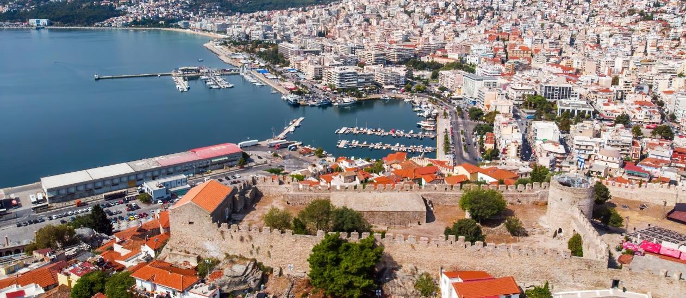

Accessible file Microsoft Word
The file was checked with the Microsoft Accessibility Checker and no accessibility issues were found. People with disabilities will not have difficulty reading it.
Note: This Guide has been transcribed and is available in the following alternative accessible formats:
- Accessible file Adobe PDF
- Accessible file MS Word
- Equivalent plain text format (TXT)
- Equivalent audio version MP3, with synthetic voice via TTS technology (text-to-speech)
- Accessible HTML according to the WCAG 2.0 standard, at AA compliance level (Large Print)

Download
the version that best suits your needs
L

Disclaimer
NCDP is not responsible for any inaccurate or outdated information. Even though every effort has been made to provide the most accurate information and information regarding the accessibility features of the infrastructure included in this Guide, until the date of issue, the NCDP bears no responsibility, nor can it be held accountable for any changes or omissions or inaccuracies that may exist.
From the release of the Guide to date, some destinations may have modified their infrastructure and services in terms of accessibility for visitors with disabilities, and their opening hours and pricing policies may change.
Please contact local authorities directly before your visit to verify the information that is important to you.
If any of the information in this Guide needs updating, please email your comments to accesskavala@gmail.com.
Failure to present a destination in this Guide, for example because it was not possible to contact the relevant authorities, does not imply that this destination is inaccessible or unfamiliar to visitors with disabilities.
NCDP bears no responsibility for information coming from individuals.
NCDP is not involved and does not bear any responsibility in the services provided of the projected points and infrastructures.
NCDP is not involved in any transaction between the displayed infrastructure and the visitors.
NCDP cannot control, nor is it responsible for the content of third-party websites mentioned in the Guide and does not guarantee or promise anything about them. All links to third party websites are the sole responsibility of the user.

Guide dogs for blinds and assistance dogs for people with disabilities
According to Greek law (Laws 3868/2010, 4235/2014 and 4238/2014), access is allowed for guide dogs and assistance dogs for people with disabilities everywhere. However, these dogs must be certified as such.
The Guide refers to companies that, unaware of the law, have stated that they do not accept guide dogs or assistance dogs, so that prospective visitors are fully informed of the attitude they may encounter.
Terminology
Accessible WC: Specially designed WC intended for the service of people with disabilities and especially people with wheelchairs.
Accessible room: Specially designed room or temporary residence intended for the accommodation of people with disabilities and especially people with wheelchairs.
Special parking spaces for the people with disabilities: Special spaces marked with appropriate markings and intended exclusively for the use of vehicles of persons with disabilities.
Accessible space: Space accessible to wheelchair users. Where there are predictions for the visually impaired or hearing impaired, they are explicitly mentioned.
Accessible swimming pool / beach: When it is stated that the swimming pool of an accommodation or a beach / coast is accessible, it is understood that there is wheelchair access to the surrounding areas. It is not understood that there is a specific provision for wheelchair users to enter the water unless this is explicitly indicated.
Accessible lift: The elevators found to have a satisfactory door opening (automatic and over 82 cm), satisfactory dimensions of free space both in front and inside the cabin, control panel at a suitable height for people in wheelchairs, and other specifications for visually impaired and hearing impaired (embossed buttons, visual and / or audible floor announcements, etc.).

A few words about Kavala
Kavala is a seaside city, built amphitheatrically at the foot of Mount Symbol, in Eastern Macedonia, between Thessaloniki and Alexandroupolis.
The city was founded by Thassian settlers in the 7th century B.C. and originally had the name "Neapolis". It was a member of the Second Athenian Alliance until its conquest by King Philip of Macedonia, who founded Philippi (modern-day Krinides) which was the first capital of Macedonia. In 54 A.D. Apostle Paul landed in Naples and founded in Philippi the first Christian Church in Europe. In the Byzantine years, it was renamed Christoupolis, while in 1380 and after the Ottoman Conquest, it took the name Kavala that it bears to this day.
At the beginning of the 19th century, tobacco growing began in Kavala, being an integral part of the history of the city for over 150 years, as well as the reason why the city is rich and prosperous. Since 1918, about 50 tobacco factories have been operating in Kavala, while the 160 tobacco warehouses employed half of the country's tobacco workers (approximately 14,000). However, the global financial crisis that erupted in 1929, the fact that the profession became less "protected" and the withdrawal of many men from the tobacco industry led the largest tobacco center in the Balkans to a sharp decline.
Nowadays, it is the seat of the municipality of Kavala and the capital of the Regional Unit of Kavala. It has one of the largest passenger ports (Apostolle Pavlos) in Greece and one of the most important commercial ports in the country and the Mediterranean (Commercial Port PHILLIPOS II). It also has one of the largest fish ladders in the Mediterranean with trade both domestically and internationally.
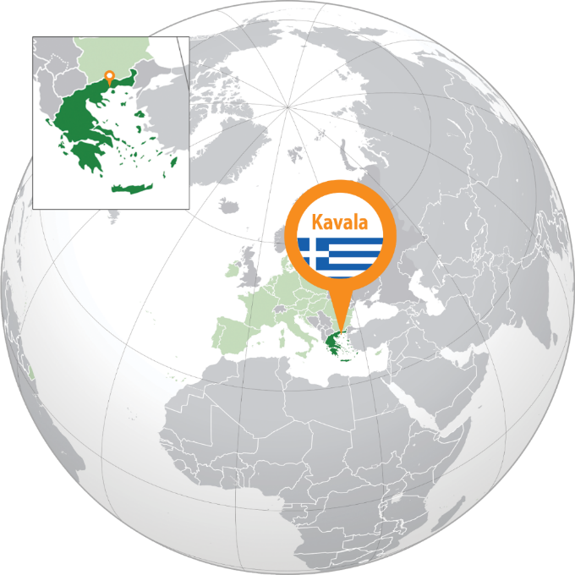

Even today it is still the center of production, processing and marketing of marbles in our country, to produce fertilizers, with the largest fertilizer industry in Greece, to produce and export -mainly in Europe- agricultural products (grapes and asparagus) and to be the most important tourist destination east of Thessaloniki, with about 500,000 visitors from Greece and abroad.
Kavala is a place that nature has endowed with rare beauty, with a rich history, glorious past and many attractions and monuments worth visiting. In Kavala, the surrounding area and Thassos, there are endless kilometres of coastline with clear blue waters and white sand that will surely impress even the most demanding visitor.

L
More about the story of the city
https://cutt.ly/Abm9qho (PDF)
https://cutt.ly/IbWhO1s (HTML)
Useful maps
Printed: https://cutt.ly/gbmN9FJ Interactive: https://cutt.ly/JbTNZlm
Detailed: https://cutt.ly/WbmMmbm
Satellite: https://cutt.ly/BbmVWEa
Prefecture: https://cutt.ly/bbm1fg0
Official website of the Municipality
www.kavala.gov.gr

How to get

By car
Kavala is about 650 km from Athens and 150 km from Thessaloniki and is easily accessible by road through a state-of-the-art closed international highway, the Egnatia Road.

L

By bus
In addition, there is the option to reach Kavala by intercity transport (KTEL) from Athens, Thessaloniki, Drama, Xanthi and Alexandroupolis.

INTERCITY BUS OF KAVALA - TOURS S.A.
 +30 2510 833744
info@ktelkavalas.gr
 www.ktelkavalas.gr

Kavala Station
4 Metropolitan Chrysostomou 4, 65403 Kavala
+30 2510 222294 (Athens-Thessaloniki), +30 2510 223593 (Drama-Xanthi-Eleftheroupolis-Chrysoupolis, Nea Peramos & locally)

Eleftheroupoli Station
+30 25920 23222

Thassos Station
+30 25930 22162
By airplane
Also, 30 km east of the city there is the International Airport of Kavala "Alexander the Great", which connects the city by air with domestic and European destinations with regular flights, as well as charter flights.

KAVALA’S AIRPORT "ALEXANDER THE GREAT"

Nea Karvali Provincial Road (PO Box 180),
64200 Chrysoupoli
L
+30 25910 53400 (Call Center)
d5ist@hcaa.gr
www.kva-airport.gr


By boat
L
If one wants to travel by boat from Attica, there is the ferry connection between Lavrio and Kavala 4 times a week with the duration of the trip ranging from 16 to 21 hours.

By train
Finally, one can travel by train but will need to disembark in Drama (36 km distance from Kavala).

TrainOSE
14511

Ferry connections with Aegean islands

From the port of Kavala

The ferry connections of the port of Kavala include direct itineraries to at least 20 ports on islands in the North and East Aegean.
L
Most ferry services from Kavala are to Lemnos and Agios Efstratios. Even in winter there are several weekly itineraries to these two islands.
Also, from Kavala there are itineraries to Lesvos, Chios, Samos, Ikaria and Fourni. There is at least 1 weekly itinerary that connects these islands with Kavala.

Kavala Port Authority
+30 2513 505430 &
+30 2510 223716 & 108

From the port of Keramoti
L

At 40 km from the center of Kavala, next to the airport, is the port of Keramoti, where ferries to Thassos start very often, which, with its numerous archaeological sites (Acropolis, ancient port, ancient market, ancient theatre, etc.), the holy abbeys and the many monasteries in combination with its wonderful coastline, receives many hundreds of thousands of tourists annually.

Keramoti Port Authority
+30 25910 51204

Tourism in Kavala
The Prefecture of Kavala is a popular tourist destination for Greeks and foreigners, mainly Balkans, Russians, and Turks, throughout the year) resulting in a continuous upward trend of visitors exceeding 1.5 million per year.
Perched at the foot of Mount Symbol, Kavala, like a balcony in the Aegean, opens its arms, ready to receive you and introduce you to its secrets. To travel you from antiquity to the present, to tell you stories from the past, when he met Philip II, the Apostle of the Nations Paul and the Governor (ruler) of Egypt Mehmet Ali, to take you by the hand and lift you up in the narrow cobbled streets of the old town of Panagia up to the Fortress, to reveal beaches of unprecedented beauty and nearby destinations for getaways full of emotions, to entertain you at festivals and numerous cultural events throughout the year, treat fresh fish, tsipouro and kourabiedes.
Apart from the deep blue sea and the clean sandy shores, the very good hotel infrastructure, the various thermal springs, the Prefecture of Kavala is also a place of Christian and archaeological interest.
Remarkably close to Kavala is the ancient city of Philippi, on the road of the Old Egnatia Road, the most important archaeological site of Eastern Macedonia with its ancient theatre and castle. It was held there in 42 B.C. the well-known battle of Philippi between the assassins of Julius Caesar and the loyal generals of Rome Antonius and October with the supremacy of the latter.
Ancient Amphipolis, on the shores of the river Strymon and on the ancient Egnatia Road, is a reference point with the historical monument of the Lion of Amphipolis and the Macedonian tombs of great archaeological value. Another archeological site is the Byzantine Palace in the current site of Nea Peramos.

YouTube:
https://cutt.ly/DbTQWsT
L
Informative leaflet:
https://cutt.ly/9bmBfcH

Useful information about Kavala

The permanent population of the city amounts to 58,790 inhabitants, while in total the municipality of Kavala has 70,501 inhabitants (according to the 2011 census).
Kavala is a large city with a good road network and all modern amenities and infrastructures. It has banks, gas stations, pharmacies, a general hospital, and supermarkets.
Also, departments of the International University of Greece operate in the city.

Shopping
Stores:
- MO-SA: 08.00-14.00 and
- TU, TH, FR: 18.00-21.00 (summer period) and
17.30-20.30 (winter period)
Supermarket (summer & winter period):
- MO-FR: 08.00-21.00
- SA: 08.00-20.00
Tourist, souvenir & pastry shops: flexible hours.
Street Market (“Laiki Agora”): SA morning in the parking lot of the Prefecture.

Pharmacies
Find here all the pharmacies of Kavala: https://cutt.ly/FbT1iGW
Overnight and on-duty pharmacies: www.vrisko.gr/efimeries-farmakeion/kabala

Useful telephone numbers
- European Emergency Telephone Number: 112
- Police - Immediate Action: 100
- Immediate help (ΕΚΑΒ): 166 & +30 2513 501688
- Fire Department: 199
- Forest firefighting: 1591
- Tourist Police: 171 (1571)
- Tourist Police of Kavala: +30 2510 622246
- Municipal Police: +30 2513 500220 & 2510 500221
- Electric Energy (DEI): 1050 (Damages) & +30 2510 242505 (Centre)
- National Tourism Organization (EOT): +30 2510 227409


Visitor Information Center
L
Eleftherias Square, 65302 Kavala
+30 2510 231011
touristinfo@kavalagreece.gr
The Visitor Information Center is a structure of DIMOFELIA which has been operating since 2003 and covers the needs of tourist information for the Municipality of Kavala and the wider area.
The building in which it is housed is located in a central part of the city, in Eleftherias square (El. Venizelou and Ionos Dragoumi corner), serving the visitors and the residents of the city.

Working hours:
- MO-SA 08.00 – 21.00 (summer period)
- MO-SA 08.00 – 20.30 (winter period)

Services
- Information
- Souvenirs
- Publications
- Forms
- Reservations
- Excursions
- Tours


Municipal Public Benefit Enterprise DIMOFELIA
L
117 Omonia str.,
65402 Kavala
+30 2510 831388 & 831398
www.kavalagreece.gr

Accommodation

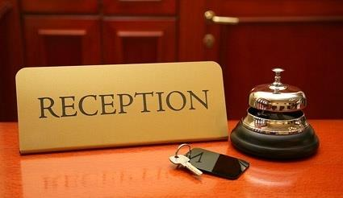
The area of Kavala has many and varied tourist accommodation of all categories.
The guest can choose to stay in a hotel, in a rented room or apartment, to have a sea or mountain view, to stay in a luxury room or in bungalows, to be close to the city center and the market or to enjoy the tranquillity of the sea, the mountain, the village or district of the Old Town.
List of approved accommodations in Kavala and the wider area: https://cutt.ly/tbT5zXz (file Word).
Kavala Hoteliers Association
+30 2510 600060 & 600250
info@kavala-hotels.gr
www.kavala-hotels.gr
On the website of the Association, you will find information about the companies - members that are located mainly in the city, but also in the rest of the Regional Unit of Kavala (except Thassos), as well as general information about the region of Kavala.

Thassos Hoteliers Association
+30 25930 23610
www.thassos-hotels.com & https://cutt.ly/jbT60Cq
On the website of the Union, you will find information about the accommodation of the Thassos island.

Hotels

Acropolis (2 stars)
0,1 km from the center
29 El. Venizelou str., 65403 Kavala
+30 2510 223543
hotel-acropolis@hotmail.com
www.hotel-acropolis.com
Centrally located in Kavala, Hotel Acropolis offers air-conditioned rooms with free Wi-Fi and views of the harbor, castle or city.
Booking 7,7
TripAdvisor #21 accommodation with the best quality-price in Kavala

L

Airotel Galaxy (4 stars)
0,2 km from the center
27 El. Venizelou str., 65403 Kavala
+30 2510 224812
info@airotel.gr
www.airotel.gr
Centrally located in Kavala, close to shops, restaurants and bars, Airotel Galaxy offers a terrace with city and sea views.
Booking 8,6
TripAdvisor #2 hotel in Kavala

L

HOTEL Imaret (5 stars)
0,5 km from the center
30 Th. Poulidou str., 65110 Kavala
+30 2510 620151
info@imaret.gr
www.imaret.gr
It is housed in a historical monument, in a unique location. It has been tastefully renovated, combining authentic Ottoman architecture with modern luxury.
Booking 9,4
TripAdvisor #3 hotel in Kavala

L

HOTEL OCEANIS (3 stars)
0,5 km from the center
32 Erithrou Stavrou str., 65403 Kavala
+30 2510 221981-5
info@oceaniskavala.gr
www.oceaniskavala.gr
Oceanis Hotel is centrally located, directly opposite the Archaeological Museum.
Booking 8,4
TripAdvisor #5 hotel in Kavala

L

HOTEL ESPERIA (3 stars)
0,7 km from the center
4 Erithrou Stavrou str., 65403 Kavala
+30 2510 229621-4
info@esperiakavala.gr
www.esperiakavala.gr
Esperia Hotel is centrally located in beautiful Kavala and offers views of Rapsani Beach. Features a sun terrace and free Wi-Fi throughout.
Booking 8,3
TripAdvisor #7 hotel in Kavala

L

HOTEL NEFELI (2 stars)
0,7 km from the center
50 Erithrou Stavrou str, 65403 Kavala
+30 2510 227441-4
info@nefeli.com.gr
www.nefeli.com.gr
Hotel Nefeli is ideal for those looking for an easy-to-find accommodation in the heart of the city. Completely renovated, in a classic style, it also has rooms with panoramic sea views. Guests can also enjoy coffee, drinks, and snacks at the hotel’s ground floor bar.
TripAdvisor #18 accommodation with the best quality-price in Kavala

L

Vila Roza (2 stars)
0,9 km from the center
4 Velissariou str., 65403 Kavala
+359 88 571 0375
Located in Kavala, VILA ROZA (вила РОЗА) offers a restaurant, free bicycles, a gym, and a bar.
TripAdvisor #16 hotel in Kavala

L
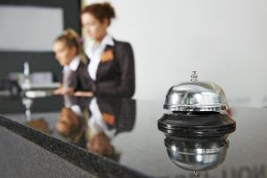

HOTEL Europa (2 stars)
1,5 km from the center
20 Irinis Athinaeas str., 65404 Kavala
+30 2510 241227
info@hoteleuropa-kavala.gr
www.hoteleuropa-kavala.gr
Hotel Europa is a family-run hotel located just 1.5 km from the city center and the port of Kavala.
Booking 8,9
TripAdvisor #9 hotel in Kavala

L


Egnatia City Hotel & Spa
(4 stars)
2 km from the center
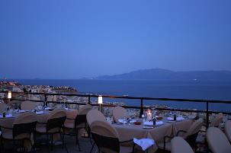
139 7th Merarhias str., 65403 Kavala
+30 2510 600250
info@egnatiahotel.gr
www.egnatiahotel.gr
Egnatia is located at the top of the hill of Kavala, just 5 minutes’ drive from the city center.
Wheelchair accessible
Booking 8,7
TripAdvisor #4 hotel in Kavala

L

hotel Lucy
(5 stars)
2,5 km from the center
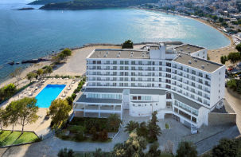
Iakinthou, Kalamitsa, 65404 Kavala
+30 2510 600060
info@lucyhotel.gr
www.lucyhotel.gr
Built in a unique location at the western end of the city, on the edge of the cape of Kalamitsa.
Wheelchair accessible
Booking 8,4
TripAdvisor #1 hotel in Kavala

L

hotel philoxenia
(3 stars)
2,5 km from the center
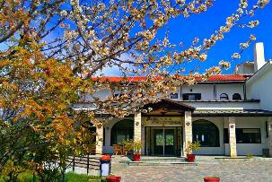
Agios Silas, 65500 Kavala
+30 2510 240070
info@hotel-philoxenia-kavala.gr
www.hotel-philoxenia-kavala.gr
Located on a hill, in a pine-covered area, with wonderful views of the sea, the mountain and the city.
Wheelchair accessible

Booking 7,5
TripAdvisor #14 hotel in Kavala
L

Bomo Tosca Beach (4 stars)
5 km from the center
1 Leoforos Paliou str., 65110 Kavala
+30 2510 244765-8 & 2310 591423
info@tosca.gr
www.tosca.gr
On the homonymous beach, bungalows above the sea.
Booking 8,5
L
TripAdvisor
#6 hotel
in Kavala
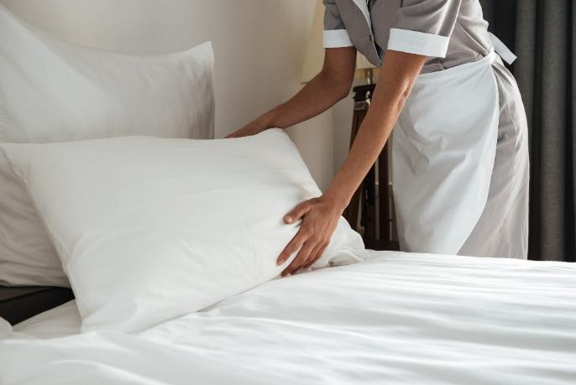

Hostels, apartments & villas

Old Town Inn
0,1 km from the center
14 Spetses str., 65302 Kavala
+30 2510 211113
The Old Town Inn is housed in a neoclassical building from 1929. It offers free Wi-Fi.

Booking 9,5
L
TripAdvisor #4 accommodation with the best quality-price in Kavala

Onar Modern Luxury Apartments
0,2 km from the center
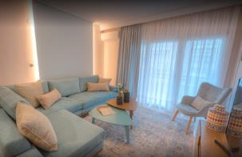
16 Aristotelous str., 65302 Kavala
+30 6972 831190
It is located close to Rapsani Beach and the Archaeological Museum of Kavala.
Features air-conditioned en suite units with flat-screen TVs, free Wi-Fi, a living room, an equipped kitchen, a seating area, a dining area, and a terrace with city views. It offers free private parking.

Wheelchair Accessible
L
Booking 9,8

Castello Boutique Rooms
0,1 km from the center
16 Hydras str., 65302 Kavala
+30 2510 83 4822
Offers units with a private balcony as well as family rooms with a terrace. Free Wi-Fi, hot tub, and room service.

Booking 9,4
L
TripAdvisor #8 accommodation with the best quality-price in Kavala

The Anthemion House
0,4 km from the center
7 Kolokotroni str., 65201 Kavala
+30 2510 211711
It is housed in a renovated neoclassical building of 1927.

Booking 9,8
L
TripAdvisor #3 accommodation with the best quality-price in Kavala

Old Town Traditional Residence
0,5 km from the center
1 Anthemiou str., 65201 Kavala
+30 6936 367187
Some rooms at the guest house have sea views.

Booking 8,9
L
TripAdvisor #20 accommodation with the best quality-price in Kavala

Adell Deluxe Apartments
0,5 km from the center
2. Kon. Tsolaki str., 65403 Kavala
+30 6980 671110
Air-conditioned accommodation with a terrace and free Wi-Fi.

Booking 9,2
L
TripAdvisor #23 accommodation with the best quality-price in Kavala

Amina Hanem Boutique Apartments
0,6 km from the center
52 Th. Poulidou str., 65201 Kavala
+30 6970 943949

Accommodation with garden, seating area, flat-screen TV and private bathroom with bath or shower.
L

PomeGranate Suites
0,6 km from the center
8 Anagenniseos str., 65403 Kavala
+30 6940 121242
https://cutt.ly/DbZsB46

Accommodation with air conditioning, satellite TV, well-equipped kitchen, private bathroom with shower, free Wi-Fi and shared lounge and garden.
L
Booking 9,9

Caldera Luxurious Residence
1,2 km from the center
7 Nyrembergis str., 65201 Kavala

https://cutt.ly/xbYIKBj
L
At a distance of 600 m. from Perigiali beach. Features free Wi-Fi, air conditioning, garden and terrace.

Our House/Luxury Studio
1,4 km from the center
30 Voulgaroktonou str., 65404 Kavala
+30 6947 562711

The air-conditioned apartment with garden view, 1 bedroom, kitchen with dining area and bathroom with shower. Free Wi-Fi.
L
Booking 8,9

Beautiful apartments
2,4 km from the center
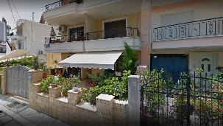
6 Kornarou str., 65404 Kavala
+30 6942 212005
Air-conditioned apartment with garden views. Free Wi-Fi is available throughout.

Wheelchair accessible
L
Booking 9,0

Camping
The area of Kavala gives the opportunity to those visitors who wish an alternative way of accommodation to choose from a series of organized campsites, which offer all the facilities and amenities provided.
The National Tourist Organisation (EOT) approved campsites in our area have one thing in common: they are located a short distance from the sea, thus offering residents the opportunity to enjoy the beauties of the coast easily, quickly, and economically.

Batis MULTIPLEX
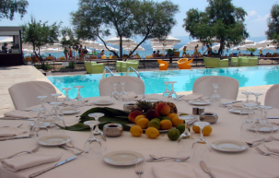
4th km Ringroad Kavala-Thessaloniki, 65500 Kavala
+30 2510 245918
info@batis-sa.gr
www.batis-sa.gr
Well-organized entertainment space, which offers young and old unlimited possibilities for relaxation and fun throughout the day, from early in the morning until late at night. There is a camping of 100 places in this area.

It has Rooms / Facilities for Persons with Disabilities
L

Camping Alexandros
Alexandros Ypsilantis, 64006 Nea Karvali
+30 2510 316240, 316347 & 316355
camping.alexandros@yahoo.gr
www.campingalexandros.com

It is located in an excellent location with a private beach and 20,000 sq.m. green for your own tent, caravan. It also has wooden bungalows and cottages for rent.
L

CAMPING AT KRINIDA PELOTHERAPY
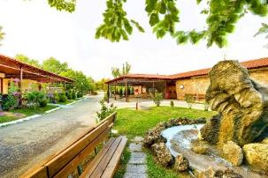
64003 Philippi of Kavala
+30 2510 516162
info@pilotherapia.gr
www.pilotherapia.gr

In the same area where the thermal waters and the therapeutic clay of the Krinides Pilot Clinic originate, is the camping of the facilities, with a capacity of 55 places - 165 people.
L
It has Rooms / Facilities for people with disabilities.

CAMPING Paradiso
National Road Thessaloniki-Kavala, 64007 Nea Iraklitsa
+30 25940 21595 & +30 6976 311258
camping_paradiso@yahoo.gr
www.paradisokavala.gr
«A real paradise 18 acres that combines simplicity but also cosmopolitan life»

The complex is located in Nea Iraklitsa just 13 km from the city of Kavala.
L

Airbnb
The number of accommodations available through the airbnb platform is constantly increasing, having already reached about 300 accommodations (50 houses, 200 apartments, 10 mansions, 10 residential complexes), for different tastes and budgets. 77% of the accommodation has 1 or 2 rooms and 14% has 3 rooms.
The average daily rate is set at around 50 euros in the winter months and around 75 euros in the summer.
Apart from the city of Kavala, we also find many listings for accommodation in Nea Karvali, Amygdaleona, Filippos, Krinides and Zygos.
Specially accessible accommodations were not found during our search.


Transportations
Kavala is full of monuments, hidden beauties and resting places.
The short distances and the Mediterranean climate favour the walking and the wandering.
However, if you want to organize your time and see more than one neighbourhood in a day, the best option is to use public transportation. Public transportation is the best way to get around the city and visit other beaches outside the city. The network is comfortable, fast and well connected.
Alternatively you can travel by bicycle, train, taxi or finally by your car.

By bicycle
Most of the city center, as well as the entire coastal zone, favor cycling. But in the rest of the city, due to its amphitheater character and intense altitudes, it is almost impossible.
In the city there are no designated traffic zones exclusively for cycling (bike path), but there are shared bicycles in central parking lots.
For information on how to dispose of public bicycles, visit https://kavala.easybike.gr or contact the Visitor Information Center.

By city bus
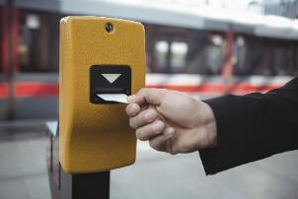

There are a total of 11 public transport lines.
L
For the beaches within the city, take the urban line 8 Kalamitsa - Batis.
Map with the routes of the city buses of Kavala: https://cutt.ly/abWnaWl
Urban buses (KTEL)
+30 2510 222912, 222130 & 222218
info@astiko-kavalas.gr
www.astiko-kavalas.gr
Note: For beaches and destinations outside the city, you should use long distance lines.

By taxi
+30 2510 232001-4 (Eurotaxi)
+30 2510 230130 (Consortium Taxi)

The city is served by a fleet of one hundred and thirty vehicles which are orange or white.
L
There are also taxis specially adapted for people with disabilities (upon reservation).

By train
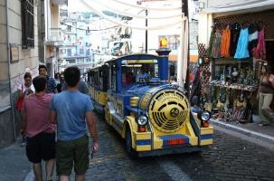
Elefterias Square, 65302 Kavala (starting point)
+30 2510 231011
The city has a small train as a free means of transport for both residents and visitors of the Old Town (“Panagia”).

Information at the Visitor Information Center
(p. 9), near the starting point of the train.
L

Car rental

By renting a motorbike or car you can explore beaches, beautiful picturesque villages and a variety of out-of-town attractions that surround Kavala.
L

Parking spaces
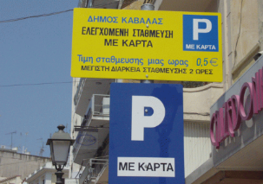
In Kavala, drivers can park their vehicles either in the parking lots or in the controlled parking zones.
In the city center there are controlled parking zones, where parking is allowed during the opening hours of commercial stores with a Parking Card (red for 1 hour 0.50 € & blue for 2 hours 1.00 €).
During market hours, parking in these areas is free.
The cards can be procured from the kiosks and from the Visitor Information Center (p. 9).
The parking of vehicles in these zones is controlled by the Municipal Police of Kavala.
L

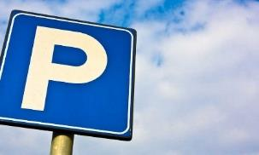
Free parking spaces
- Parking Peristeri, at the Verouleio Stadium (Chrysostomou Smyrnis Street)
- Free parking space (Ethn. Antistaseos street)
- Parking on Thassos Street
- Parking on Keas Street

Parking for a fee
- Parking NOK (Dagli street)
- Parking "Rodopi" (Mitropoleos Street)
- City Hall Parking (Damianou street)
- Parking next to the Prefecture (Erithrou Stavrou Street)
- Parking Ag. Ioanni (Velisariou street)
- Customs Parking (Port)
- Municipal Market Parking (Geor. Papandreou Square)
- Parking Ag. Georgiou

Walk in the city
Kavala favours walking. So, make the most of your mood for walking and enjoy the history, architecture and multicultural elements of the city up close. Especially if it is a sunny day, you can stop in one of the parks or gardens of the city to take a breath or even on the beach of Rapsani or Kalamitsa to enjoy a swim in their clear blue waters.
In terms of accessibility for people with disabilities, it is noted that the city has:
- accessible pedestrian access zones for wheelchair users and visually impaired people, over much of its tissue
- parking spaces for people with disabilities in central parts of the city
- ensuring access to public buildings (with wheelchair ramps, etc.)
- audible traffic lights at the Erithros Stavros-Dagli junction
- provisions that allow people with disabilities to enjoy their bath with comfort and autonomy, including the installation of SEATRAC mechanism of autonomous entry into the water on the shores of Kalamitsa and Perigiali
- modern amusement park for people with disabilities that operates in the area of the Municipal Sports Center of Kalamitsa “Alexandra Dimoglou”

So, use the following shortcuts to see in detail the accessibility conditions in each of the following streets and parts of the city, as recorded by autopsies.

Roads
L
16th Taxiarhia
7th Merarhia
Averof
Andros
Velissariou
Votsi 1 2 3 4
Vyronos
Dagli 1 2 3 4
Damianou
Doiranis
Ethnarhou Makariou
El. Venizelou
Erythrou Stavrou 1 2 3
Epirus 1 2 3 4
Thasou
Thiras
Ionos Dragoumi
Kassandrou
Kastro
Keas
Klitou
Koranou
Koudouriotou
Kritis
Kyprou
Lavras
Mitropoleos 1 2 3
Nikis
Nyremvergis
Omonias
Palaiologou 1 2 3
Palaion Patron Germanou
Pargas
Romanou
Skra
Syrou
Timiou Prodromou
Hydras
Filikis Eterias
Filipou
Filoptohou 1 2 3
Hrysostomou Smyrnis

Pedestrian streets
L
Kosti Palama-Pavlou Mela
Agiou Nikolaou
Arhaiologikou Mousiou
Ethnikis Antistaseos


Squares
L
Meeting and rest points.

ELEYTHERIAS SQUARE
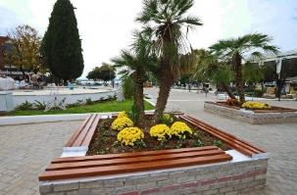
Eleftherias Square, old Fuat Square, is the central square of Kavala. The square has the shape of a rectangle and is surrounded by the streets of Omonia in the north, El. Venizelou to the south, Doiranis to the east and Ionos Dragoumi to the west.
In the northern part of the square is the Outdoor Municipal Shelter which occasionally hosts speeches, performances, pre-election events, etc.
From the side of Ionos Dragoumi starts the Municipal Train for Panagia (see p. Σφάλμα! Δεν έχει οριστεί σελιδοδείκτης.), while a little further is the Tourist Information Center (see p. 9)

To the south you will find the monument of Alexander the Great as well as an EasyBike shared bicycle station.
L

KAPNERGATI SQUARE
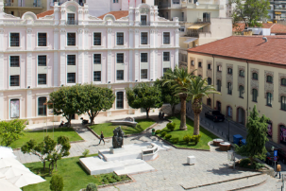
Kapnergati Square, on Kassandrou and Averof Streets s the second important and central square of the city after Eleftherias Square. In Kapnergati square is the large building of the Municipal Tobacco Warehouse, as well as the monument of Kapnergati, to which the square owes its name.



Parks & Gardens
L
Green areas and recreation areas.

MUNICIPAL GARDEN OF HEROES
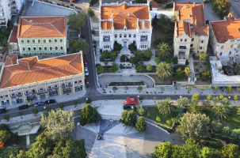
To the left of Kyprou Street, below the City Hall, extends the Municipal Garden and extends to El Venizelou and Averof. The Municipal Garden began to take shape in 1922 - 1924. Until then it had evergreen trees and wild forest vegetation and was considered a remote area from the then city center.

Apart from the monument of heroes, there is also a recreation area with a fountain and benches for the rest of the citizens after a long walk in the city, as well as a refreshment room called “Kipos” (Garden).

FALIRO MUNICIPAL PARK
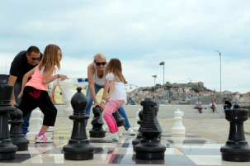
Here you can start or end your walk, depending on the day and the mood.
It has rest areas, basketball court, skateboard, playgrounds, especially designed area for walking the dog. Events, concerts, a bazaar, and everything else imaginable are often organized here.
Continue to the Amusement Park (Louna Park) and the characteristic pier, where you can enjoy the view of the peninsula with the Fortress, the picturesque houses of Panagia and the docking boats.

Suggestions for a walk in and out of town

OLD TOWN “PANAGIA”
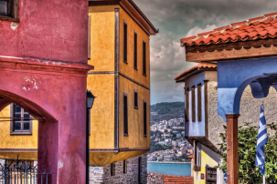

The walk in the Old Town of Kavala is an experience that you want to live and relive: to walk in the cobbled alleys, to gaze at the magnificent view, to read favourite readings, to taste and smell, to discover its successions a long journey of a city that, among other things, has plenty of rich stories to tell. On the rocky promontory and around its walls, the Old Town is ideal for time travel and history.
L
Map: https://cutt.ly/sbASFi1

KAPNERGATI SQUARE, KYPROU STREET & MUNICIPAL GARDEN
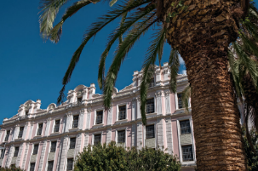
L

Another nice route in the city is the one that can be followed from Kapnergati Square to the paved Kyprou street with the beautiful neoclassical buildings that exist from the smoke era and to reach the Municipal Garden Municipal Garden.
Map: https://cutt.ly/obAJQb9

THE PORT OF KAVALA
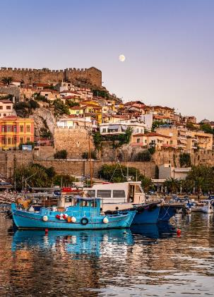

Another beautiful route that you must follow is the one that leads to the passenger port of the city, starting from the Municipal Park of Faliro.
L
Map: https://cutt.ly/vbADk8b

ANCIENT EGNATIA ROAD
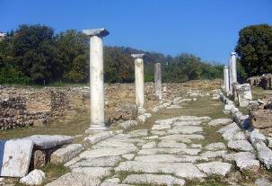

The city of Kavala is fortunate to maintain on its outskirts a large section of the ancient Egnatia Road. This is the old cobbled road, which, until the beginning of the 20th century, was the main highway coming from the west. As a touring route, this piece does not present particular difficulties or long length, but its historical value is great.
L
Map: https://cutt.ly/3bWfFCq

THE SURROUNDING FOREST
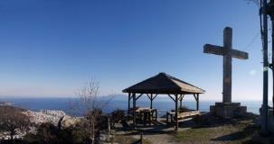

In Kavala, an important suburban forest surrounds the city on its northern side. It extends from Agios Silas and Constantio boarding school, to the area of Chorafa and Agios Athanasios, and is offered for everyone seeking contact with nature, exercise, and leisure.
L
Map: https://cutt.ly/1bWf59R

KAVALA - OLD KAVALA (THE Path OF WATER)
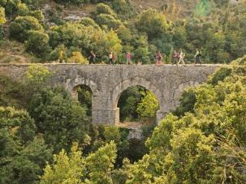

This is the most important path outside the city, not only because of its aesthetic value, but mainly because of its special historical and cultural elements. The route is divided into two parts. The first half, with a length of 5 km, reaches from Kavala to “Mana tou Nero” (“Mother of Water”) at the location "Tria Karagatsia". The second half with a length of 5.5 km, reaches the village of Old Kavala.
L
Map: https://cutt.ly/ubWga26
Information leaflet: https://cutt.ly/pbm2luh

Attractions

Kavala has a rich cultural heritage and many places of historical interest. Apart from the monuments of the Ottoman Period, it is also famous for its tobacco warehouses, as tobacco production was one of the main occupations of the inhabitants of Kavala.
That is why the city is also called "Mecca of Tobacco".

Here are the main attractions, first the ones inside the old town and then the rest.

OLD TOWN (“PANAGIA”)

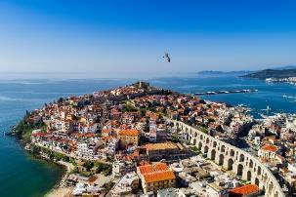
TripAdvisor: #2 Attraction in the preferences of the visitors of Kavala
L
Inhabited uninterruptedly from the 7th century BC the district of Panagia is the original historical core of the city of Kavala. Panagia, the old town of Kavala with its castle, has all those elements that will take you back in time.
There are so many attractions, neoclassical buildings, and picturesque alleys to explore. Typical examples are Mohammed Ali Square, where his statue and house, the Church of the Assumption and the Hussein Bey Mosque are located.
Each corner has its own unique identity and will take you back in time.
There are no paved paths in the area with “guides for the blinds”. In general, wheelchair access to the streets and alleys of "Panagia" is difficult, but not impossible.

BEACH WALL
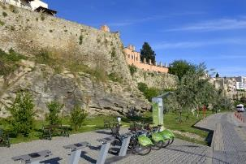
Opposite the parking lot of the Kavala Customs, 65302 Kavala

The strong walls of the Thassian colony were probably built at the beginning of the 7th century BC. Today it is a great place for walking, cycling and rest. There is also an automatic shared bicycle disposal system at the site.
L
On the route there is paving with a “guides for blinds”. The route is wheelchair friendly.

5TH HIGHT SCHOOL OF KAVALA
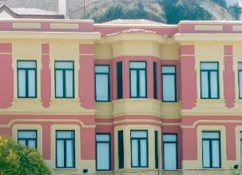
16 Th. Poulidou str., Kavala 65201
The 5th High School of Kavala is a typical Ottoman building of the city, which was built between 1902 and 1908 by the Turkish tobacconist Patsajik, as a residence.
Hundreds of Kavala’s residents were imprisoned and tortured in the basements of the building during the occupation.

IMARET
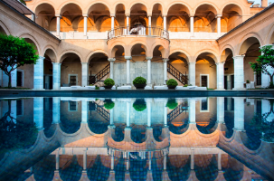
30-32 Th. Poulidou str., Kavala 65201

TripAdvisor: #5 Attraction in the preferences of the visitors of Kavala.
L
Walking on Theodorou Poulidou Street, one encounters Imaret. A huge edifice built in 1817 by Mehmet Ali Pasha as a place for Islamic teaching.
Born in Kavala in 1769, he occupied the office of Governor (regent) of Egypt in 1805 and never forgot his beloved birthplace. Thus, he built in one of the most beautiful areas of the city a seminary, Imaret, with an area of 4,500 sq.m.
Today, this masterpiece of Islamic architecture functions as a luxury hotel.

HOUSE, MUSEUM & STATUE OF MEHMET ALI
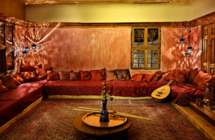
Mehmet Ali Square, 65110 Kavala
+30 2510 620515
info@mohamed-ali.org
www.mohamed-ali.org

TripAdvisor:
#4 Attraction in the preferences of the visitors of Kavala.
L
Mehmet Ali's house was built in 1720 and is still in exceptionally good condition. The location of the house is such that it has a panoramic view from all sides.
Next to the house of Mehmet Ali is placed his bronze statue, work of the sculptor Demitriadis, which was a gift of the Greeks of Alexandria to the people of Kavala.
Wheelchairs are not accessible to the house and museum premises (there are stairs).
Working hours
Daily (except MO), 10.00-14.00
SA & SU also works as a cafe.
Ticket price
General admission: €2
Educational excursions - students: €1
People with Disabilities & Unemployed: free entrance

holy church of the dormition of the virgin MARY (koimiseos tis theotokou) (panagia)
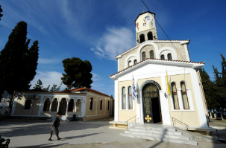
69 Th. Poulidou str., Kavala 65201
+30 2510 224527 & 222159
www.im-philippon.gr

The Holy Church of the Dormition of the Virgin Mary (Koimiseos tis Theotokou) is located in the historic district of Panagia, within the walls of the peninsula, where half of the inhabitants and families that lived during the Turkish occupation were Greek Orthodox Christians. In this small district, those Greeks who lived during the times of slavery had the mind of the Christian faith so deep that it operated since then a monastery in the same area where the church is built today, in which he even consecrated, near his mother, Saint Philotheos Kavaliotis.
L

Lighthouse of Kavala
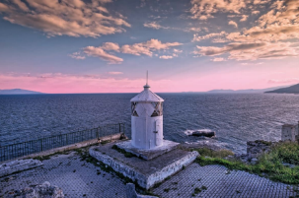
Th. Poulidou (end), Kavala 65201
The “area of the lighthouse”, as always mentioned by the locals, is one of the most enchanting areas of Panagia and one dares to hide good secrets of the past.
You can see the sea panoramically, enjoy the sunset and if the sky is clear, you can see in the background the island of Thassos, in the west Mount Athos and in the east the beaches of Keramoti.

The route to the lighthouse is wheelchair friendly. There is no paved path with “guides for the blinds”.
L

Khalil Bey Mosque
(Old Music)
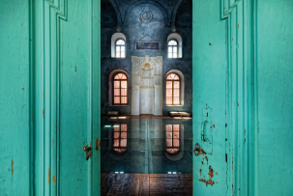
26 Ali Mehmet str., Kavala 65201
+30 2513 500100
TripAdvisor: #11 Attraction in the preferences of the visitors of Kavala
Going up to the Castle we meet the Khalil Bey Complex which includes the mosque of the same name of Khalil Bey of the early 20th century, an older minaret, perhaps of the 16th century and a madrassa (seminary). The mosque is built on the foundations of an early Christian basilica. The red building is the mosque and the blue the mistress. The 8 rooms of the midwife are preserved in good condition.

Wheelchair access is not possible (there are stairs).
L

ACROPOLIS - MEDIEVAL FORTRESS (CASTLE)
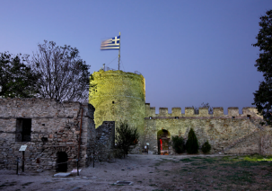
Ermionis, Kavala 65201
+30 2510 838602 & 831358
tourism-castle@kavalagreece.gr
www.castle-kavala.gr
TripAdvisor: #1 Attraction in the preferences of the visitors of Kavala
Most of it was built in the first quarter of the 15th century. It succeeded the Byzantine Acropolis of Christoupolis - which had been destroyed in 1391. After the interventions for the preservation, the current role of the acropolis as a place of rest and walks for the inhabitants of Kavala was systematized. Today in the courtyard there is an open-air theater for music, theater, dance and events of all kinds. It has a refreshment room and a shop for information and souvenirs.
Wheelchair access is not possible (there are stairs).
Information leaflets https://cutt.ly/7bmBB9C
https://cutt.ly/sbmNYCM
Visiting hours
MO-SU 08:00-20:00 (Summer months) and 08:00-16:00 (winter)

Ticket price
L
General admission: €2,5
Reduced ticket: €1,5

ARCHES “KAMARES”
(the medieval aquaduct)
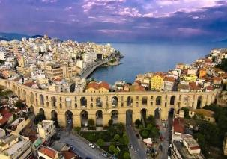
8 Dimokratias str.,, 65201 Kavala

TripAdvisor:
#3 Attraction in the preferences of the visitors of Kavala
L
These imposing arches are perhaps one of the famous and impressive sights in Kavala. Initially, they were part of a system, the Medieval Aqueduct, which carried water from Mount Symbol to the rock of Panagia in the Old Town. It is one of the great public works executed by Sultan Suleiman the Magnificent with the vizier of Ibrahim Pasha. Having a total length of 6.4 km, the aqueduct was built with a significant slope due to the location. It survives to this day, about half a millennium later, intact and in very good condition.

HOLY CHURCH OF AGIOS NIKOLAOS (MONUMENT OF APOSTLE PAUL)
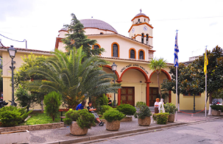
1 Agiou Nikolaou str., Kavala 65302
+30 2510 2510 224527
www.im-philippon.gr

TripAdvisor:
#7 Attraction in the preferences of the visitors of Kavala
L
The wonderful relationship of the national Apostle Paul with Europe and its peoples, begins with the divine vision "going in Macedonia help me" (Proverbs 16: 9). He is called to Macedonia to teach the word of Christ to the Europeans.
The first European soils that Apostle Paul trampled on in 49 AD, are in the city of ancient Naples, as Kavala was then known, already an important port and commercial center.
In fact, Kavala is not accidentally called Christoupolis for 600 years, before it got its current name.
At the place where he landed, there is today the Church of Agios Nikolaos, in the courtyard of which the modern inhabitants of Kavala built the brilliant mosaic monument 'Step of St. Paul', work of the painter Vlasios Tsotsonis and the mosaicist Pino Pastorutti to honor fact.
Then the Apostle walked on the ancient Egnatia Road that survives to this day and crossed the 12 kilometers to the city of Philippi, "that is the first city of Macedonia colony" (Pr. 16, 12), where he founded the first Church in Europe. and baptized the first European Christian, the pious Lydia.
He was accompanied by the evangelist Luke, the apostle Timothy and Saint Silas, in whose honor the homonymous Holy Monastery of the Apostle Silas operates today in Kavala.
Museums

ARCHAEOLOGICAL MUSEUM
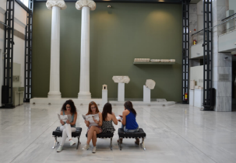
17 Er. Stavrou str., Kavala 65403
+30 2510 222335

TripAdvisor: #9 Attraction in the preferences of the visitors of Kavala
L
It is considered one of the most important museums in Greece of its kind. It hosts representative finds from the wider region of Eastern Macedonia and Thrace. The history of the Museum of Kavala together with that of the Archaeological Service in the area begins in 1934. It is now presented in its most complete form, built next to Faliro Park and at the left end of the port.
In the Museum you can find:
- Authentic copies of exhibits of Greek Museums (Casts, Byzantine icons, Coins, etc.) produced by the Archaeological Resources Fund (TAP), which is the competent state body for their production.
- Applications and creations inspired by ancient Greek art.
- Archaeological publications of TAP.
Opening hours: 08.00-15.00 (except Monday)
Ticket price: General Admission: €2 Over 65 years: €1 Students: Free.

MUNICIPAL TOBACCO MUSEUM
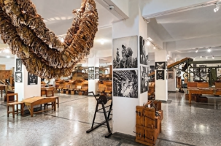
4 K. Palaiologou str., 65403 Kavala
+30 2510 223344
info@tobaccomuseum.gr
www.tobaccomuseum.gr
TripAdvisor: #6 Attraction in the preferences of the visitors of Kavala
The Tobacco Museum of the Municipality of Kavala is a thematic museum, which includes objects and archival material for the cultivation and production of tobacco, its agricultural and commercial processing, industrial tobacco products and exhibition tobacco samples.
The uniqueness of the Tobacco Museum is found not only in the fact that it includes and exhibits the commercial processing of oriental tobacco (which are not found in any other museum in the world), but also in the fact that it is a technological museum Macedonia and Thrace.
Note: There is the possibility of group tours beyond the working hours, by telephone contact with the museum.
YouTube video: https://cutt.ly/lbABxri
Working hours:
MO-FR 08.00-14.00

SA 09.00-13.00
L
Ticket price:
€2 normal
€1 reduced.

MUNICIPAL NAVY MUSEUM
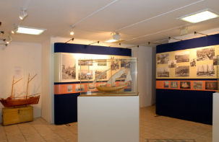
Chrysostomou Smyrnis, Kavala
+30 2510 240668
nmkav.gr@gmail.com
www.nmkav.gr

TripAdvisor:
#10 Attraction in the preferences of the visitors of Kavala
L
The sea has always been the dominant element of the city during all these 40 centuries of its existence, the life and the feeder of its economy. For this reason, a group of friends from Kavala started the effort to realize a dream, to establish a naval museum that collects and preserves relics and memories from the naval history, tradition and seamanship of the city.
The Ministry of Culture has designated as monuments (incorporating elements of the local shipbuilding tradition), three traditional boats that belong to the Maritime Museum and are donations from the residents of Kavala.
It is a member of the Maritime Museums of Greece and since 2008 a full member of the International Council of Museums (ICOM).
Working hours:
MO-SA 10.00-12:00
Visits of groups and schools, beyond working hours by telephone contact.
Free entrance

MUSEUM OF REFUGEE HELLENISM
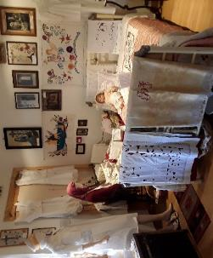
57 Gallikis Dimokratias str., Kavala
+30 2510 243508 & +30 6937 457121, 6947 023222, 6945 340340 (mobiles)

Tripadvisor:
#17 Attraction in the preferences of the visitors of Kavala
L
A Museum created by the Association of Asia Minor of Kavala "Memory of Asia Minor", ninety years after the Catastrophe, and keeps alive the memory of the unforgettable homelands of the East, the uprooting and the refuge, the struggle of our ancestors to take root in their new homeland.


L

HISTORICAL AND LITERARY ARCHIVE OF KAVALA
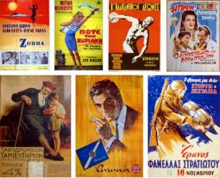

183 Omonias str., 65110 Kavala
+30 2510 224845 (MO-FR 10:30 - 13:30).
roudometof@primehome.com
www.ilak.org
It is a non-profit public benefit institution (Civil Company).
Its library consists of more than 30,000 books, magazines, calendars, and newspapers from the 16th century until today. Due to the rarity of its books, it does not function as a lending library. You can study the books you want on the spot and make a small number of free photocopies.

Old mansions & buildings with history
The city of Kavala breathes in the rhythms of its history and the visitor can at every step discover a hidden treasure in its monuments, attractions, and tobacco warehouses. Magnificent corners with buildings-jewel of the urban landscape, streets and narrow streets that will transport you to another era, images that sprung through postcards.
A very nice route in the city is the one that can be followed from Kapnergati square to the paved Kyprou street, where it meets successively the following buildings with a different story each.

MUNICIPAL TOBACCO WAREHOUSE
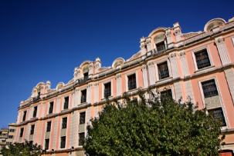
Kapnergati Square, Kavala 65403
+30 2510 222706
Tripadvisor: #15 Attraction in the preferences of the visitors of Kavala
L
It was built around the end of the 1900s as a tobacco warehouse of the Turkish tobacconist Kizi Mimin.
Today the building belongs to the Municipality of Kavala who renovated it so that now it can host various cultural events.

MONASTERY OF LAZARISTS (MONI LAZARRISTON)
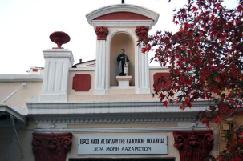
6 Kyprou str., Kavala 65403
+30 2510 223163 & 2310 539559

It was built between 1888-1892, while the Parish was founded in 1900 together with the permanent establishment of the Mission Fathers. Originally the building was used as a Catholic church guild of Lazaristes and then as French Consulate.
L
Today it functions again as a Catholic Church (Apostle Paul).

MANSION VIX (CITY HALL b’)
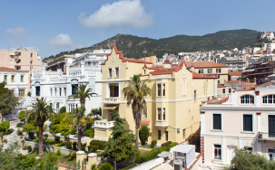
8 Kyprou str., Kavala 65403

It belonged to the German baron Adolf De Zolnai Vix. Architecturally, the building has many features in common with the current town hall building (10 Kyprou Street).
L
Today, it belongs to the Municipality of Kavala and houses some of its services.

CITY HALL
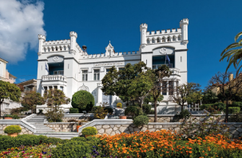
10 Kyprou str., Kavala 65403
It was built around 1985 by the Hungarian tobacconist Baron Pierre Herzog and is a miniature of a Hungarian tower.
It is probably the most impressive building in the city, with a unique and completely "foreign" architectural line in Kavala.

Since 1937, the Municipality of Kavala is housed here.
L

MANSION tokou (old CITY hall)
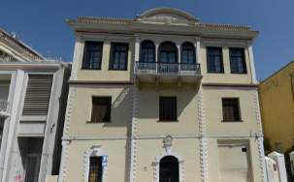
12-14 Kyprou str., Kavala 65403

It was built in 1879 as the residence of the tobacco merchant Dimitrios Tokos. It is a building of Ottoman neoclassicism and baroque and at the same time preserves some elements of the local tradition. Today it has been restored with great sensitivity and houses the 12th Ephorate of Byzantine Antiquities of the Ministry of Culture.
L

GREAT CLUB
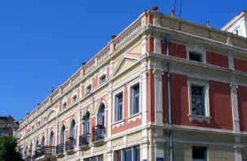
14 Kyproy str., Kavala 65403

TripAdvisor:
#14 Attraction in the preferences of the visitors of Kavala
L
A few meters after the City Hall is the building of the Grand Club. In the neoclassical form of the building there are several elements of the ancient Greek tradition (pseudo-columns, capitals, cornices, etc.). Today it is used for cultural events, while on the ground floor it has an exhibition space as well as the space with the offices of the “Ombudsman”.

OLD GIRLS 'SCHOOL
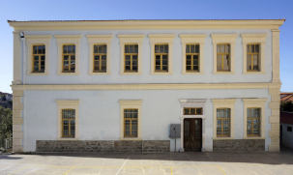
1 K. Palaiologou str., Kavala 65403
+30 2510 223035

It is located above the Grand Club. Its construction was completed in 1894. It was built and equipped with donations from prominent tobacco merchants of that time. Today the building houses the 10th Primary School of Kavala.
L

MUNICIPAL CONSERVATORY
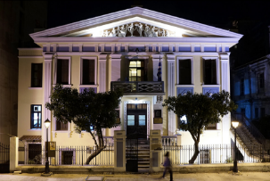
67 El. Venizelou str., Kavala 65403

+30 2510 222119
L
info@dok.gr
http://dok.gr
The Municipal Conservatory of Kavala is the building with the cleanest neoclassical elements (gables, false columns, window frames, rhombic geometric shapes, etc.), which was built before 1884, as the residence of a rich tobacconist.
Attractions in the
rest of the city

PORT OF SLAUGHTERHOUSES
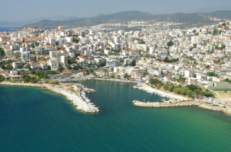

In the "back port" of the city, in the neighbourhood of Slaughterhouses, the sea view is accompanied by appetizers in the taverns of the area. And just when you thought the city was over, you see another picturesque harbor. The port in the old "Slaughterhouses" has everything you ask for. Taverns with fresh fish and meat, cafes, beautiful views and quiet away from the noise of the city.
L

PORT / COASTAL ROAD
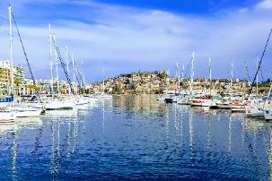

This port has played a key role in the evolution and development of the city from antiquity until today. It was founded by the Thasians at the end of the 7th century BC and kept open the roads to the Aegean and the coasts of Central Asia.
L
From 2002 the commercial traffic was transferred to the port of N. Karvali "Filippos B '", so now the port serves the passenger traffic to and from Thassos, Lemnos, Mytilene and Samothrace, tourism, fishing fleet and water sports.
The heart of the city beats today on the coastal road that leads to the port. Everything you need for beach walks among palm trees, squares, and bars. Take it on foot or using public bicycles.

LUNA PARK
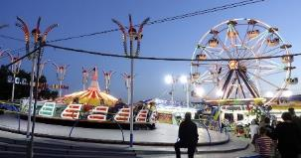
Eth. Antistaseos str., Kavala 65403
+30 6946 583737
www.lunaparkkavalas.gr

Religious places
In many parts of the area the visitor can meet buildings and monuments of worship of different doctrines and religions, which reveal the multicultural heritage of the area over the centuries.
The heritage of Greek Orthodoxy is an integral part of the national identity and is a pole of attraction for visitors. The first European church was founded in Philippi in 49 AD by Apostle Paul and the first European Christian was baptized Saint Lydia, Philippia.
There are many early Christian monasteries and churches that are preserved, with their remarkable illustration, their mosaics, their frescoes, and their rare icons.

PILGRIMAGE BAPTISTERY OF ST. LYDIA PHILIPPISIA (PRISON OF APOSTLE PAUL)
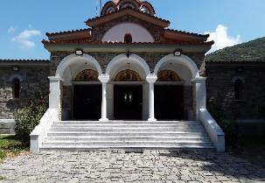
Lydia, 64003 Kavala
+30 2510 516944
imphnth@otenet.gr
www.im-philippon.gr

It is located on the river Zygaktis, west of ancient Philippi, where according to the narration of the Evangelist Luke (Acts chap. 11), Apostle Paul baptized the first Greek and European Christian, Lydia of Filippi.
L
Every year, on the day of the memory of Isapostle Saint Lydia of Philippi on May 20, after the end of the festive Hierarchical Divine Liturgy, clergy and people with His Eminence the Metropolitan of Philippi of Neapolis and Thassos are present at the river Zigakti where adult Baptism is performed. The moments are unique and extremely moving.
According to the Acts of the Apostles, Apostle Paul was imprisoned in Philippi when he healed a child who had a divinatory spirit. Today above the market of Philippi there is the propylon of the great Early Christian Church. A narrow corridor leads to the crypt of the Church in a small dark building with two spaces covered by arches. This building is believed to have been the prison of Apostle Paul.

HOLY MONASTERY OF ST. APOSTLE SILAS OF KAVALA
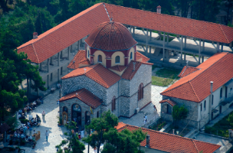
3rd km National Road Thessaloniki-Kavala, 65500 Kavala
+30 2510 242511 & 223222
www.im-philippon.gr
Tripadvisor: #15 Attraction in the preferences of the visitors
It celebrates on July 30.
Just three kilometers outside Kavala, following the national road Kavala-Thessaloniki, exactly where it joins the surviving sections of the old famous Egnatia Road s the Holy Monastery of Saint Apostle Silas.
It is a men's monastery and belongs administratively to the metropolis of Kavala.
From the monastery, the view of Kavala is wonderful. In front of it are the beautiful beaches with their natural harbors. Deep in the bay are the well-known oil wells. And beyond, the pearl of the northern Helladic islands, Thassos.
The city itself, literally perched on the rocks and ravines that form as the mountains descend almost abruptly into the sea, almost completely justifies the reflection of all these experts who attributed the name of the city to the peculiarity of the land.
This picturesque area, surrounded by a wonderful rich green, was not chosen at random for the construction of the monastery. During the tradition, the Apostle Paul and his associates Silas, Timothy and Luke sat down to rest at this point.
This is also mentioned by the marble column that is today in front and a little to the left of the Katholikon of the monastery:
“IN ANCIENT TRADITION, THE HOLY APOSTLES PAUL AND SILAS RESTED HERE DURING THEIR FIRST MISSIONAL VISIT TO PHILIP.”

L

HOLY METROPOLITAN CHURCH OF HONORABLE PRODROMOS
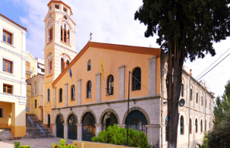
46 El. Venizelou str., 65403 Kavala
+30 2510 223177
www.im-philippon.gr

In 1864 the Greek Orthodox Community of Kavala acquired the right to build a district outside the city fortress and its first concern was to build a church for the religious needs of the faithful, the church of Timios Prodromos, in a place that was a countryside for the inhabitants of the city and a pilgrimage dedicated to Zoodochos Pigi.
L

HOLY CHURCH OF ST. ATHANASIO
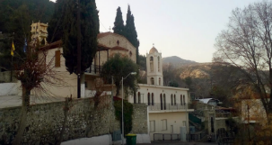
109 Ag. Athanasiou str., 65201 Kavala
+30 2510 222330
www.im-philippon.gr

It is the third oldest church in Kavala, after the, Timios Prodromos and the Assumption of Virgin Mary, built at the eastern end of the city, in a sloping and picturesque area.
L

HOLY CHURCH OF ST. GEORGE (Agios Georgios)
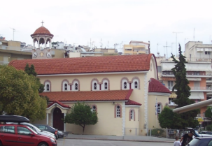
1 Perdika str., 65302 Kavala
+30 2510 224398
www.im-philippon.gr
The Church of Saint Georgios of Kavala is in the homonymous area in the city center.
It was founded and established by refugees after 1922, mainly from Thrace and more specifically from the Stern of Eastern Thrace, who settled in the area of ​​Agios Georgios.
There was a mosque where a committee placed a cross and decided to establish it as a Holy Temple in the name of St. George and to place icons and relics brought from the unforgettable homelands.
In 1983 the church and the chapel of Saint Marina were demolished (its image was transferred to the left aisle of the current church) and in 1985 the new building is ready, which is equipped with all the necessary furniture and sacred utensils for its operation.
In 2004 the Hagiography on the wall begins.

The church is a three-aisled basilica with a dome.
L

HOLY CATHEDRAL CHURCH OF ST. APOSTLE PAUL
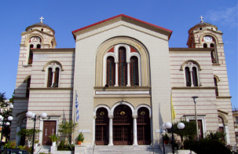
1 Ioakim Sgourou str., 65302 Kavala
+30 2510 222113
www.im-philippon.gr
L

The Cathedral of St. Paul the Apostle was founded to honor and extol the fact that in this city - then Naples, subsequently Christoupolis and today Kavala - arrived for the first time in Greece, as well as in Europe in general, Apostle of the Nations Paul.
The construction of the Holy Temple began with a group of devout Christians in the early 1900s. Finally, the foundation stone was laid in 1905 by the Metropolitan of Xanthi Ioakeim Sgouros, after the Greek Community had previously sought the consent of the Turkish Administration, as the city was still under Turkish occupation as the city was still under Turkish occupation.

Holy Church of the Dormition of the Virgin Mary (KoimisI Theotokou)
See above, p. 21.

HOLY CHURCH OF ST. NIKOLAOS
See above, p. 22.

CATHOLIC CHURCH OF APOSTLE PAUL
See above, p. Σφάλμα! Δεν έχει οριστεί σελιδοδείκτης..

holy CHURCH OF PROPHET ILIA
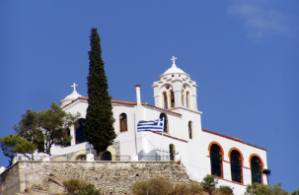
3 Parthenonos str., 65302 Kavala
+30 2510 223823

www.im-philippon.gr
The history of this temple, which dominates imposingly on the top of a rock high above Kavala, begins in 1928, when on the initiative of some Christians a small wooden chapel was built in honor of the Prophet Ilias.
Poor and unpretentious, he accepted the reverent pilgrimage of the excursionists, who found the opportunity to climb up there to enjoy the beauty of the gulf of Kavala and, in its depths, Thassos.
Along with the appearance of the chapel, the first inhabitants appear, who will create the first core of the settlement of Profitis Ilias.

holy church of PANAGIA EIKOSIFOINISSA
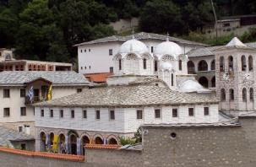
62047 Proti Serres
+30 25920 61566

The Holy Monastery of Panagia Eikosifoinissa is one of the sacred places of Eastern Macedonia that continues today to be a pole of attraction for many believers, who come to worship the “handmade image of the Virgin” and to calm down in its peaceful environment.
L
It is located on the Kavala-Serres road, just after Kormista, on the north side of Paggaio in a verdant location, at an altitude of 743 m.
There is a Guesthouse.
Working hours
Daily 05.00-14.00 and 16.00-21.00 (summer schedule)
Daily 05.00-14.00 and 17.00-19.00 (winter schedule)
Outside Kavala

HISTORICAL ETHNOLOGICAL MUSEUM OF GREEKS OF CAPPADOCIA
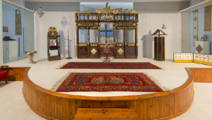
Culture House (Stegi Politismou), 64006 Nea Karvali
+30 2510 316192 & 616648
+30 6974 000014 (mobile)
info@stegi-karvalis.gr
www.stegi-karvalis.gr

Award from the EU of the best museum in Europe for the year 1997.
L
L
It has been operating since 1995 from the Cultural Center of Nea Karvali together with the Center for Cappadocian Studies.
Working hours:
MO-FR 08.30- 13.00
Afternoons and weekends by appointment
Ticket Price
General admission: €3 Groups: €2 Schools: €1

AKODISMA
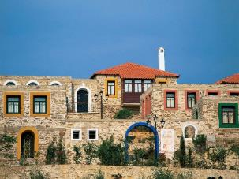

At 12 km outside the city of Kavala is the refugee village of Nea Karvali. On the outskirts of the village is a secluded hill, on which is built the Folklore village of Akontisma, named after the Romans, who once inhabited this area.
Traces of civilization have existed since the 4th century BC. The ancient Egnatia Road also passed through there.

In the Folklore village there is the Historical Ethnological Museum of Greeks of Cappadokia as well as a guest house with 22 rooms.
L
Philippi
18.5 km from Kavala
Powerful kings of the ancient Greek world, Roman generals and thousands of soldiers, the most important Apostle of early Christian times and the first European Christian.
Find the traces they left behind with a single visit to the unique Archaeological Site of Philippi.

ARCHAEOLOGICAL SITE
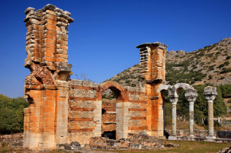
Krinides, 64003 Philippoi
+30 2510 516090 & 516251
efakav@culture.gr
https://cutt.ly/ybQ7sBJ

UNESCO World Heritage Site.
L
A few kilometres outside the city, you will find the city that took its name from the father of Alexander the Great. There, the hoe brought to light ruins from the Hellenistic, Roman, Byzantine and Early Christian periods, such as those of the octagon, the Roman market, the royal churches, the walls and of course, the Ancient Theatre of Philippi, which has now been restored and normally performances.
Visiting hours
MO-SU: 08:00-20:00 (summer months)
Και 08:30-15:00 (winter months)
Ticket price
General Admission (at the Archaeological Museum of Philippi): Full: €6, Reduced: €3.
Single ticket (the single ticket is valid for the Archaeological Museum of Philippi and the Archaeological Site of Philippi): Full: €8, Reduced: €4.
Visitors over the age of 65 from EU countries as well as pupils and students from non-EU countries, are entitled to a reduced ticket.
Admission is free for children under 18, students from EU countries, unemployed Greek citizens, and People with Disabilities.

ANCIENT THEATRE
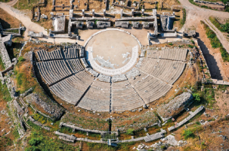
The ancient theatre of Philippi is a remarkable and important monument. It is located at the foot of the citadel hill and rests on the eastern wall of the city of Philippi. Although it has undergone many changes over the centuries and some interventions to be able to host the Philippi Festival, it retains many of its elements.

ANCIENT CITY
Opposite the ancient theatre of Philippi are the ruins of the ancient city. The city got its name in 356 BC. by the father of Alexander the Great, Philip II.
The archaeological site of Philippi can offer the visitor a mixed tour, since the excavations have brought to light ruins from the Hellenistic, Roman, Byzantine, and Early Christian periods. The octagon, the Roman market, the early Christian royal sections of the city walls, are the best known of these.

ARCHAEOLOGICAL MUSEUM
The Archaeological Museum of Philippi is located on the outskirts of the archaeological site and has two sections of exhibition spaces for the permanent presentation of the findings from the excavations of the ancient city:
Section Α΄: Occupies the entire ground floor. This section presents archaeological (inscriptions, sculptures, pottery, coins, jewellery), historical and supervisory material of the city of Philippi and its area from prehistoric times to the end of Roman antiquity.
Section Β΄: Occupies the floor of the building. It presents the Christian city (inscriptions, architectural members, mosaics, vases, coins) from the early Christian years of prosperity to its shrinkage in the 7th AD. century and until its final desolation after the Turkish conquest at the end of the 14th century.

People with disabilities have access to the Museum premises.
L

Nestos river
Escape to nature
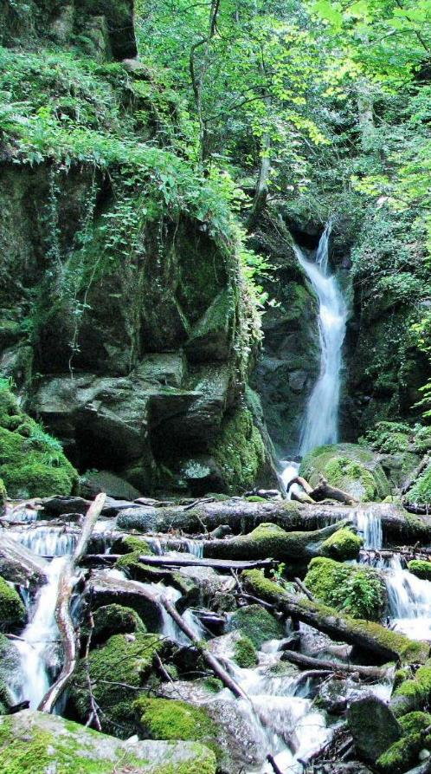

Nestos is one of the five largest and most important rivers in Greece. It originates from Mount Rila in Bulgaria and flows into the Thracian Sea.
L
It is located about 28 km east of Kavala and is the natural border of Macedonia and Thrace. The flow of the river from the Greek-Bulgarian border to its estuary, has created several ecosystems that host many plants and animals, many of which are rare or endangered.
The visitor can walk the paths of Nestos on foot or from the special facilities by bicycle enjoying, can do rafting, kanoe-cayak, etc.
Visit the village of Toxotes (40 km) from where the excursions start and live a unique experience in nature.

RECEPTION CENTER OF THE RIVER FOREST
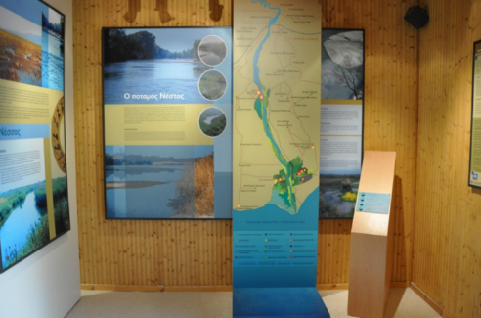

Nestos Monastiraki Forest, 64011 Keramoti
L
+30 2510 461807 (Forestry Office)

INFORMATION CENTER OF NESTOS DELTA
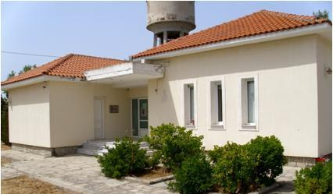

64011 Keramoti +30 25910 51831
L
infonestos@fd-nestosvistonis.gr
www.fd-nestosvistonis.gr
Working hours
MO-FR 09.30 – 15.30 Weekends by arrangement
From the end of 2020, next to the Center begins a new fully accessible ecotourism route for people with disabilities!
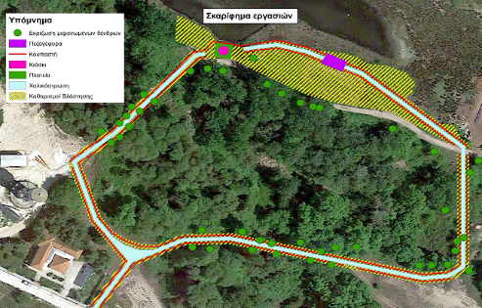

Beaches and Coasts

Kavala is one of the few cities in Greece that has four organized beaches within its urban fabric.
If you are looking for quiet moments by the sea, a little further from the city you will find more secluded beaches.
The picturesque Palio (Old), Kalamitsa with the youth beach bars, Iraklitsa, Peramos and Batis with the green scenery and the beautiful restaurants, and of course the spectacular Ammolofoi (Dunes) with the crystal-clear waters and the light sandy beach are the necessary stops on the Kavala coastline.

RAPSANI
Inside the city
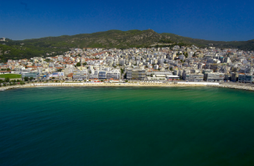

“Child of the city” almost in the center, near the park of Faliro, for those who can not leave the city.
L
Organized and with free admission.
Awarded the Blue Flag.
You can reach by buses No1, No4, No5, No8 and No10.
There is a tavern and refreshments on the coast.
It does not have infrastructure / facilities for people with disabilities.

PERIGIALI
2 km east
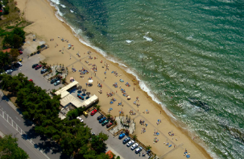

TripAdvisor:
#19 Attraction in the preferences of visitors
L
Located at the eastern entrance of the city. Admission is free and the Municipality provides bathers with umbrellas and chairs.
Awarded the Blue Flag.
There is access by public transport of the city with buses No2, No3 and No11.
Free parking is available. There are fish taverns in different parts of the coast that serve fresh fish and other local dishes.
It has infrastructure / facilities for people with disabilities.

aspri amMos (“white sanD”)
3 km east
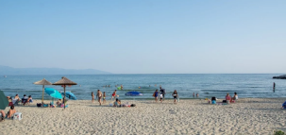

TripAdvisor:
#13 Attraction in the preferences of visitors
L
A wonderful sandy beach and organized beach with fish taverns. Aspri Ammos (“White Sand”) beach is covered mainly with fine sand. The water is clean and transparent. The beach is protected from winds by two hills, so there are rarely strong waves. Suitable for young children and beginner swimmers. It is easy to reach the beach and park the car in front of the sand.
It does not have infrastructure / facilities for people with disabilities.

NEA KARVALI
11 km east
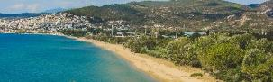
The beach has a southern orientation, is entirely sandy and is not organized. However, sun loungers and parasols are available in some areas. Within the immediate area of the beach there is an organized camp area with a total capacity of 180 people.

It does not have infrastructure / facilities for people with disabilities.
L

aMmoglosSa keramotis
34 km east
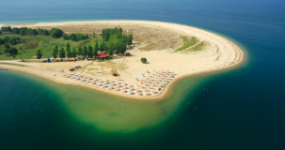

The sea and the pine forest of the coast of Keramoti compose a typical Greek image. It is a strip of land that penetrates the sea and extends into the blue of the Aegean. The sandy beach attracts many visitors in summer thanks to its relatively shallow and calm waters, highlighting the ideal for families.
L
Organized beach bars, cafes, and taverns mainly with seafood, make the area an ideal summer destination. One can go to Keramoti by intercity bus to Xanthi and then continue on foot or taxi to the beach.
Awarded the Blue Flag.
It does not have infrastructure / facilities for people with disabilities.

KALAMITSA
3 km west
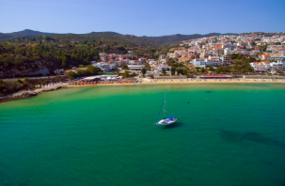
L

Tripadvisor:
#8 Attraction in the preferences of visitors
Organized beach of the Municipality of Kavala at the western entrance of the city.
Awarded the Blue Flag.
It hosts many bathers daily during the summer months.
It is one of the first choices of the city youth because the entrance is free.
There is access by public transport of the city with buses No4, No5 και No8.
There is also free parking.
There are taverns on the coast and in the surrounding area that serve Greek and international cuisine, as well as refreshments and bars for cool breaks.
It has infrastructure / facilities for people with disabilities.

BATIS
4 km west
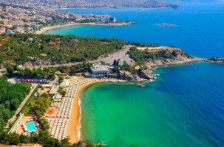
Picturesque bay with organized beach and the autonomous multipurpose space BATIS MULTIPLEX. The visitor will also find water toys, swimming pools, restaurant, pool bar, beach bar and playground.
The coast is 250 meters long, while the average width is estimated at 30 meters.
It has specialized lifeguard staff.
Awarded the Blue Flag.
To enter the beach and use the facilities there is an entrance fee.
Access is by city bus No8 during the summer months and intercity bus o Nea Peramos.
Finally, it has a spacious parking lot with free entrance. .
L

It has infrastructure / facilities for people with disabilities.

toska
5 km west
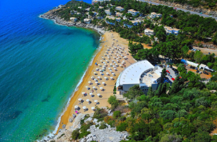

Awarded the Blue Flag, for its clear waters and organization.
L
Access is by intercity bus to Nea Peramos.
In the facilities there is the Hotel 4* Bomo Tosca Beach, a restaurant and a bar. On the first line of the sea, in a large area, with a small pine forest, with private sandy beach, comfortable rooms, restaurants, bars, kids club.
It has specialized lifeguard staff.
Admission with a ticket.
It does not have infrastructure / facilities for people with disabilities.

palio (OLD)
6 km west
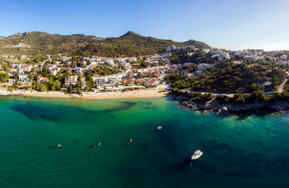
At a distance of 6 km from Kavala you can find Palio. A picturesque seaside resort that attracts many bathers in the summer as it is a traditional holiday center for both Kavala residents and tourists.
Access is by intercity bus to Nea Peramos.
Along it there are wonderful lacy shores with beach cafes and taverns for all tastes.
The beach is organized mainly in the eastern part, with infrastructure such as sunbeds, umbrellas, showers, bins, and trash cans.

It does not have infrastructure / facilities for people with disabilities.
L

Costa Vita
7 km west
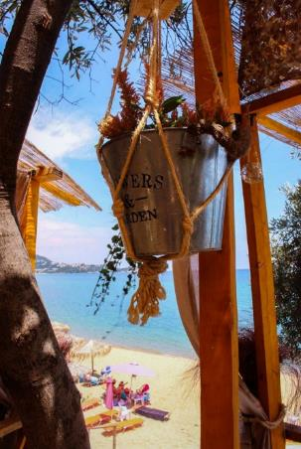
The natural beauty and the clear blue waters compose an environment unique to the area, which is an attraction for people of all ages.
It also has ample parking space.
Includes the homonymous Beach -Bar.

Access is by intercity bus to Nea Peramos.
L

nea iraklitsa
13 km west
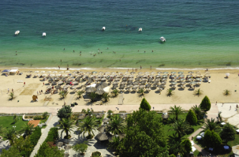
Nea Iraklitsa, one of the most beautiful villages in the area, has a wonderful blue sea with a sandy beach which can be enjoyed either as a swimmer or eating in one of its many wonderful taverns.
Access is by intercity bus to Nea Peramos.
Awarded the Blue Flag.
It is organized and has parking. Admission is free, with free parasols and sun loungers, showers and changing rooms. The organized camping Paradiso camping Paradiso is located in the area.

It does not have infrastructure / facilities for people with disabilities.
L

remvi
14 km west
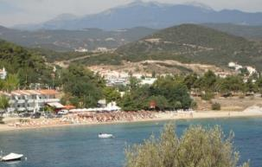
L

Ideal beach for families who want to enjoy a quiet swim with their children. There is a tavern and a café bar.

Nea peramos
16 km west
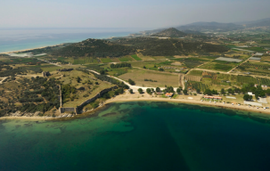

Nea Peramos competes in beauty with the most famous tourist places of Greece, as it has amazing beaches and unique taverns with the best fish in the area.
L
Access is by intercity bus to Nea Peramos.
Opposite the beach of Nea Peramos, vacationers see a rocky islet known as Fidonisi (Snake Island).
It has infrastructure / facilities for people with disabilities.
From Nea Peramos there is also a ferry connection with Thassos.

vrasida
20 km west
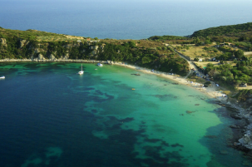
Between Ammolofoi (Sand Dunes) and N. Peramos, behind the hill of the Byzantine Palace, stretches the peninsula of Vrasidas. The many small beaches and coves in combination with the green mountains and the rock formations that surround the area, challenge you to swim and explore.
Access is by intercity bus to Nea Peramos. The road to the cape starts from the entrance of the castle. It is unpaved but its condition is quite good and can be crossed by all types of vehicles.

It does not have infrastructure / facilities for people with disabilities.
L

amMolofoi (SAND DUNES)
18 km west
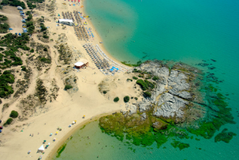
L

The Ammolofoi (Sand Dunes), with their crystal-clear waters, are located 2 km from Nea Peramos.
It is ranked in the list of the ten most beautiful beaches in Greece and for this reason attracts crowds every summer.
It has a length of 3 km and combines fine sand with crystal clear waters creating the illusion that the visitor is on an exotic beach!
It has been awarded the Blue Flag for its clear waters.
The beach is divided into three parts with the presence of rocks and their names starting from the east to the west are: first Ammolofoi (Sand Dunes), second Ammolofoi (Sand Dunes) and third Ammolofoi (Sand Dunes).
It has an organized beach with beach bars, sunbeds, umbrellas, and free parking.
Admission to all beaches is free.
For bathers who prefer something calmer and more relaxed, they can visit the Dunes again to "explore" their untapped sides.
Access is by intercity bus to Nea Peramos.
It does not have infrastructure / facilities for people with disabilities.

sarakina
26 km west
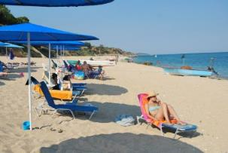

And here the landscape is enchanting… Clear waters, soft sandy beach.
L
Access is by intercity bus to Nea Peramos.
It does not have infrastructure / facilities for people with disabilities.

APOLLONIA TOWER
38 km west
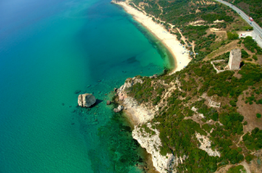
The Tower of Apollonia is located on the south side of the old National Road Thessaloniki - Kavala, between the mouth of the river Strymon and the gulf of the Free. It probably got its name from the misjudgement of the time about the exact location of the ancient city of Apollonia. The building dates back to the 14th century and had a military purpose. It was built to control the movements throughout the sea area, from Kavala (then Christoupoli) to Mount Athos.
If you follow the dirt road near the tower, you will end up with a beach that offers endless blue, calm and serenity.

It does not have infrastructure / facilities for people with disabilities.
L

OFRYNIOU BEACH
58 km west
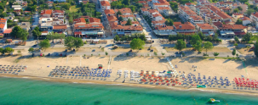
In the clear blue waters of Ofriniou beach (Tuzla) you will find a vast beach with white sand and colorful pebbles, umbrellas. Fish taverns and grills for tsipouro or ouzo at noon and for the evening come to enjoy the night life. There are hotels, rooms to let, apartments, supermarkets, lots of shops and you can find everything.
Also, from the beach start two paths for mountaineering in Paggaio.
Finally, the beaches of Kariani and Akropotamos are of unique beauty and every summer they are flooded with vacationers and visitors.

Dining & Entertainment

To Araliki
Th. Poulidou, Kavala
+30 6984 718521
https://cutt.ly/GbEVjJ1 (Facebook)
L

TripAdvisor: #1 restaurant in Kavala
Cuisine: Mediterranean, Barbecue, Greek. Special diets: Vegetarian Friendly, Vegan Options, Gluten Free Option.

Gorgkones & Magkes
2-4 Ellis str., 65302 Kavala
+30 2510 833600
https://cutt.ly/5bEMjUa (Facebook)
TripAdvisor: #2 restaurant in Kavala

Cuisine: Seafood, Mediterranean, Greek. Special diets: Vegetarian Friendly, Vegan Options, Gluten Free Options.

Balaouro
19 Thasou str., Slaughterhouse port (Limanaki Sfageion), 65201 Kavala
+30 2510 225222
balaouro@hotmail.gr
www.balaouro.gr

TripAdvisor: #3 restaurant in Kavala
L
Cuisine: Seafood, Mediterranean, European. Special diets: Vegetarian Friendly, Vegan Options, Gluten Free Options.

Sousouro
4 Ag. Nikolaou str., 65302 Kavala
+30 2510 226111
sousourokavala@gmail.com
www.sousouro.com
L
L

TripAdvisor: #4 restaurant in Kavala
Cuisine: Mediterranean, Barbecue, European. Special diets: Suitable for vegetarians, Gluten Free Options.

Tsalapetinos

36 Karaoli & Dimitriou Square, 65201 Kavala
L
+30 2511 111073
info@tsalapeteinos.gr
www.tsalapeteinos.gr
TripAdvisor: #5 restaurant in Kavala
Cuisine: Mediterranean, European, Wine Bar. Special diets: Vegetarian Friendly, Vegan Options.


To Koutoukaki
L
29 Th. Poulidou str., 65201 Kavala
+30 6946 793981
koutoukakikavala@gmail.com
https://cutt.ly/zbE2LSb (Facebook)
TripAdvisor: #6 restaurant in Kavala
Cuisine: Seafood, Mediterranean, Greek. Special diets: Vegetarian Friendly, Vegan Options, Gluten Free Options.

Delikaris ola sta karvouna

15 Psaron str., 65302 Kavala
L
+30 2510 232116
TripAdvisor: #7 restaurant in Kavala
Cuisine: Fast food, Barbecue, Greek.

Tavern Savvas
29 Thasou str., 65201 Kavala
+30 2510 225505
https://cutt.ly/AbE93UV (Facebook)
TripAdvisor: #8 restaurant in Kavala
Cuisine: Seafood, Mediterranean, Greek.

Special diets: Vegetarian Friendly, Vegan Options, Gluten Free Options.
L

Psaraki
3 Eth. Antistaseos str., 65403 Kavala
+30 2510 211750
eat@psaraki.gr
https://cutt.ly/KbE3Djo (Facebook)
TripAdvisor: #9 restaurant in Kavala
Cuisine: Seafood, Mediterranean, European.

Special diets: Vegetarian Friendly, Vegan Options, Gluten Free Options.
L

Apiko Tsipouro Restaurant
2 Erithrou Stavrou str., 65302 Kavala
+30 2510 227173
info@hellothessaloniki.gr
www.apiko.gr

TripAdvisor: #10 restaurant in Kavala
Cuisine: Seafood, Mediterranean, Greek. Special diets: Vegetarian Friendly, Vegan Options, Gluten Free Options.

Fish Tavern Kyra Vangelio
176 Nuremberg str., 65201 Kavala
+30 2510 225846
https://cutt.ly/qbE75FU (Facebook)

TripAdvisor: #11 restaurant in Kavala
L
Cuisine: Seafood, Mediterranean, Greek.

Castello Pizza
29 Th. Poulidou str., 65201 Kavala
+30 251 022 4000
https://cutt.ly/vbRwoFn (Facebook)
TripAdvisor: #14 restaurant in Kavala
Cuisine: Italian, Pizza, Greek.

Special diets: Vegetarian Friendly, Vegan Options.
L

In Koutouki of Sarris (Sto Koutouki tou Sarri)
Mall, 2nd floor
+30 6978 525344
giannisar_kav@hotmail.com
https://cutt.ly/AbRwDxh (Facebook)

TripAdvisor: #15 restaurant in Kavala
L
Cuisine: Mediterranean, European, Greek.

Paraliakon
6 Erithrou Stavrou str., 65302 Kavala
+30 2510 211005
https://cutt.ly/TbRePhm
TripAdvisor: #17 restaurant in Kavala
Cuisine: Seafood, Mediterranean, European.
Wheelchair access.

Reservations, Outdoor seating, Alcohol service, Free Wi-Fi, Credit card accepted, Waiters.
L

Palladium
4 Erithrou Stavrou str., 65302 Kavala
+30 2513 010707
palladio.s.c@gmail.com
https://cutt.ly/ZbE4pjW

Cuisine: Mediterranean, Bar, Cafe, Greek, International, European, Grill, Pub. Special diets: Vegetarian Friendly, Vegan Options.
L

Tsipouro Restaurant NEMESIS
8 Eth. Antistaseos str., Kavala 65403
+30 2512 512510
nemesis1kavala@gmail.com
www.nemesiskavala.gr
Cuisine: Seafood, Mediterranean, Greek.

Special diets: Vegetarian Friendly, Vegan Options.

Imaret Bar & Restaurant
L

30-32 Th. Polulidou str., 65110 Kavala
+30 2510 620151
L
info@imaret.gr
www.imaret.gr
TripAdvisor #3 hotel in Kavala
Restaurant of Imaret Hotel housed in the homonymous historical monument, in a unique location.

Cafe - Bar

The Brick
76 Th. Poulidou str., 65201 Kavala
+30 6944 333220
https://cutt.ly/MbE5Fs8 (Facebook)
TripAdvisor: #1 place for coffee and tea in Kavala

Outdoor Seating, Serving Alcohol, Full Bar, Free Wi-Fi, Accepts Credit Cards, Waiters.
L

Daily's Crepe & Espresso Bar
Filellinon & Ermou, 65302 Kavala
+30 2510 224185
https://cutt.ly/obE6ldo (Facebook)

TripAdvisor: #2 place for coffee and tea in Kavala
L

Caffeine Roastery-Superfoods
8 Chrysostomou Smyrnis str., 65403 Kavala
+30 2510 244434
kavala@caffeinestores.gr
www.caffeinestores.gr
TripAdvisor: #3 place for coffee and tea in Kavala
Wheelchair access.

Outdoor seating, Free Wi-Fi, Accepts credit cards.
L

Allotino
32 Erythrou Stavrou str., 65403 Kavala
+30 2510 230279
info@allotino.gr
www.allotino.gr
TripAdvisor: #4 place for coffee and tea in Kavala
Wheelchair access.

Reservations, Buffet, Parking, Free Wi-Fi.
L

Festivals, Celebrations & Events
Kavala is a place that knows how to celebrate, have fun, and entertain. Depending on the season you will visit, you will encounter a rich program with events, concerts, performances, but also traditional festivities. Whichever one you choose to go to; the only sure thing is that you will have an unforgettable time!

PHILIPPI FESTIVAL
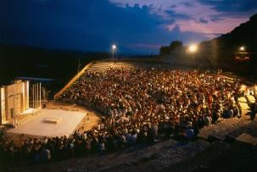
www.philippifestival.gr
It is one of the most important festivals in Greece. It takes place every summer (JUL-SEP), at the site of the ancient theatre of Philippi. Hosts performances of ancient drama, contemporary theatre, classical dance and concerts.

INTERNATIONAL FESTIVAL COSMOPOLIS
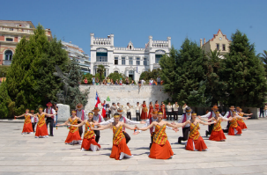
www.kavala-cosmopolis.com
A multidimensional festival organized by the municipality, with events in various parts of the city that gather thousands of visitors of all ages in Kavala.
It lasts from May to December, giving space to all kinds of music, but also to other creative arts. Since its inception in 2000, until today, it has hosted important, well-known and young artists from around the world, among them some of the biggest names of the Greek and international scene.
Search for the program from the Visitor Information Center.

FESTIVAL G.A. PAPAIOANNOU
www.dok.gr
The Municipality of Kavala in collaboration with the Municipal Conservatory organizes in July a music festival, where great artists, Greek and not, awaken with their music a variety of emotions to all participants.

ALPHABET PARADE
At Carnival, elementary school students parade through the city's main streets wearing masquerades and dancing to carnival rhythms. There are also various events, such as carnival constructions, dance and song competitions with chair lifters, clown games, karaoke, etc.

CLEAN MONDAY (KATHARA DEFTERA)
the old custom wants the people of Kavali to “catch the snake” in Kalamitsa. n recent years, this spree has taken place in Faliro Park, with music, fasting food, and creative workshops for children.

ELEFTHERIA – APOSTLE PAUL’S CELEBRATIONS
Celebrations, the second 15 days of June, for the liberation of the city in 1913 from the Bulgarian occupation troops. They peak on June 29, feast of the patron saint of the city, Apostole Paul. They take place in the Fortess, in Eleftherias Square and in other parts of the city and include painting-sculpture exhibitions, theatrical and music-dance performances, concerts, book presentations, chess games, etc.

Market - Shopping
Kavala follows the rhythms of modern life with many shops, small and large, modern, and traditional. Where does the heart of the city's shopping center beat? Most shops in Kavala are concentrated mainly on two streets. One is El. Venizelou Street and the other, the Omonias Street – without excluding or omitting the vertical straits that connect or intersect the two roads. Shops with experience in their field from generation to generation, shops with original or unique products in the world, shops that can meet your every wish and need and which will not let you pass their temptations unmoved.
At the same time, you are always just a few steps away from elegant cafes and night shops, where you can enjoy fantastic sweet and smart snacks, Greek coffee, natural juices and cold drinks or the drink of your choice, as well as local delicacies.
On its largest pedestrian street, Megalou Alexandrou Street, you will find the Shopping Center of Kavala (Mall), while on Ionos Dragoumi you will find the Municipal Market of Kavala.
Finally, every Saturday morning, in the parking lot of the Prefecture, the Street Market (Laiki Agora) of Kavala is held.

MUNICIPAL MARKET
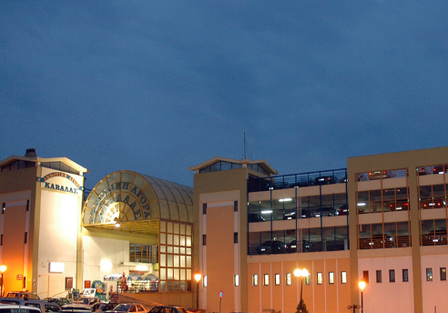

Ionos Dragoumi, Kavala 65201
L
+30 2510 835375 και 831388
citymarket@kavalagreece.gr
Here you will find shops of all kinds: fish shops, butchers, supermarkets, and various shops selling fruits and vegetables, food, beverages and nuts, confectionery, electrical items, wedding items, clothing-footwear, gardening and flowers. You will also find cash desks for payment of Public Electricity (DEI) and Municipal water supply and sewerage company of Kavala (DEYAK) bills and the Municipal Bookbinding.

shopping center (Mall)
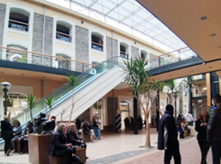
38-44 Meg. Alexandrou str., 65302 Kavala
+30 2510 231682
www.kavalamall.com

It is located on the corner of M. Alexandrou and Averof, in an old tobacco warehouse building. It can also host events or exhibitions.
L
L
Traditional products
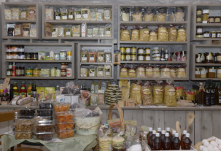

A visit to Kavala will be unforgettable, among other things for its famous traditional products that you can taste and buy, such as sweet temptations that are known throughout Greece (kourabiedes, syrupy donuts, spoon sweets, etc.), fresh fish, seafood and typical recipes of the area (salted, mackerel fur, married sardine, mussel pilaf, herring saganaki, anchovy wrapped in vine leaves, etc.), potato of exceptional taste, delicious chestnuts and local wine, honey excellent quality and in various varieties and local ouzo and tsipouro.

Souvenirs
Visit the area of Agios Loukas with its own special and colorful market but also the Port (the “Old Fishmen”) and the Old Town (Palia Poli), ideal stations for souvenirs.
You can also visit the Visitors Information Center, in Elefterias Square, where you will find albums, tour guides, books, DVDs and other small souvenirs.

Public Services

MUNICIPALITY OF KAVALA

10 Kyprou str., 65403 Kavala
+30 2513 500000, 500100, 500104 & 500196
mayor@dkavalas.gr
www.kavala.gov.gr
It is housed in the City Hall.

REGIONAL UNIT OF KAVALA
20 Eth. Antistaseos str., 65110 Kavala

+30 2513 503271
L
www.pekavalas.eu

Citizens' SERVICE CENTER (KEP) OF THE PREFECTURE OF KAVALA
20 Eth. Antistaseos str., 65110 Kavala
+30 2513 503616503619, 503621, 503623 & 503625

n.kavalas@kep.gov.gr
L
www.kep.gov.gr

Citizens' Service Center (KEP) of Kavala Municipality

11 Aminta str., 65302 Kavala
L
+30 2513 500001-4

POLICE DIRECTORATE of KAVALA

117 Omonias str., 65302 Kavala
L

municipal police

4 K. Palaiologou str., 65403 Kavala
L
+30 2513 500220 & 500221
ctpolice@dkavalas.gr


CUSTOMS
L
Port, 65201 Kavala
+30 2513 510500 & 2510 832968


COURT HOUSE
L
Tenedou, 65404 Kavala
+30 2513 500001-4
Here are housed the Court of First Instance, the Magistrates 'Court he First Instance Court Prosecutor etc.

Caring & Solidarity

CREATIVE EMPLOYMENT CENTER FOR PEOPLE WITH DISABILITIES (KDAP-MEA)
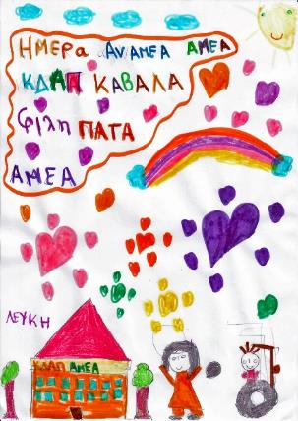
22 Chanion str., 65404 Kavala
+30 2510 241262 & 831388
It was founded in 2003 on the initiative of the Municipality and the Municipal Public Benefit Enterprise of Kavala DIMOFELEIA.
Types of diseases covered by the services:
- Sensory disabilities
- Mental health disorders
- Diffuse developmental disorders (Autism)
- Brain paralysis
- Physical disabilities
- Mental disabilities
- Down Syndrome, Noonan, Asperger, Marfan.

Services
- Sports programs
- Individual treatment sessions or outpatient clinics
- Diagnosis or evaluation
- Vocational training for adults
- Access to the open labor market
- Home services
- Day Care Center
- Programs of Socialization, Autonomous Living, Cultural, Artistic,
- Dance, Theater,
L

- Gardening – Cooking.

MENTAL HEALTH CENTRE
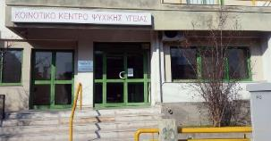
10 25th Martiou str., 65404 Kavala
+30 2510 243992 (Secretariat) and 246233 (Management)
kpy@kavalahospital.gr

It is a modern unit that belongs to the General Hospital of Kavala. It aims to promote the mental health of the population, the treatment and rehabilitation of mental disorder. Accepts people of all ages, children, teens, adults, seniors regardless of insurance.
L
L
Working hours: 08.30-14.00

Physical Medicine and Rehabilitation Center of Chrysoupolis
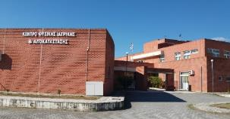
37 Pontiados str., Chrysoupoli 64200
+30 25913 50300 & 308

kekykameakavala@1028syzefxis.gov.gr
L
It belongs administratively and organically to the General Hospital of Kavala. It consists of scientific staff, which provides counselling and psychosocial support programs, as well as occupational therapy, speech therapy, physiotherapy, nursing intervention programs.

BRANCH oF CHRONIC DISEASES OF KAVALA
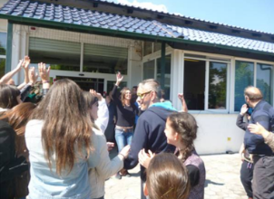
Eth. Antistaseos str., 64100 Eleftheroupoli
+30 2592 350301 & 2510 241915
kpronamth@1188.syzefxis.gov.gr

The Chronic Diseases Unit of Kavala (former Hospital) is located in Eleftheroupoli (at the 2nd km of Eleftheroupoli - Serres National Road) and since October 2013 it is part of the Social Welfare Center of the Region of Eastern Macedonia and Thrace (end of Iokasti str., area of Ag. Luke, 65404 Kavala).
The structure is characterized as an open social care unit in which pre-professional laboratories operate and high-quality treatment and rehabilitation services are provided for the people with disabilities over 18 years of age. In addition to therapeutic, there are many educational and recreational programs.
Opening hours: 07.00 - 15.00
Programs
- Laboratory of Small Crafts
- Floriculture and Gardening Laboratory
- Ceramic lab
- Physical therapy
- Psychological support
- Social service
- Occupational therapy
- Nursing care

NEW STRUCTURE FOR PEOPLE WITH DISABILITIES
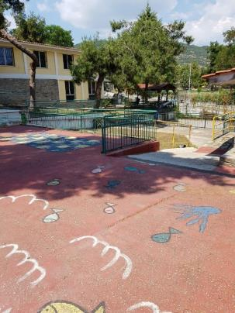
Iokastis (end), 65404 Kavala
+30 2510 241432 (12.00 - 20.00)
kkppamth@yahoo.com
L

The new structure for people with disabilities operates as a Department of the Annex of Chronic of Kavala and is housed in one of the premises of the Social Welfare Center of Eastern Macedonia and Thrace. The new structure underwent renovation and maintenance work while at the same time there is the infrastructure needed to support the access and education of people with disabilities.
The structure, currently serves people with disabilities over 18 years of age, providing the following services free of charge:
- Department of pedagogy, creative employment, and small crafts
- Psychological support
- Social Worker’s Office
- Physical Education and Sports Program.
It is open from 12 noon to 8 pm. The trainees work certain hours depending on the program of each one, which is created according to their needs and possibilities.

workshop OF SPECIAL VOCATIONAL EDUCATION AND TRAINING
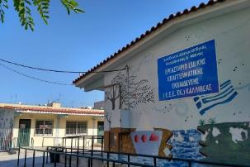
Nea Karvali, 64006 Kavala
+30 2510 316201
mail@eeek.kav.sch.gr
http://eeek.kav.sch.gr
It is a special school that started operating in September 2012 and is located in N. Karvali. It is the only Public Special School of Secondary Education in the Prefecture and is addressed to students aged 14 - 22 years, graduates of special or general primary school, with special learning difficulties and educational needs.

Students can study in the Special Laboratories of Vocational Education and Training for 5 to 8 years, depending on their specializations and educational needs.
L

Centers for the Open Protection of the Elderly (KAPI)
The Municipality of Kavala operates six (6) Centers for the Open Protection of the Elderly (KAPI) that offer free primary health care to all citizens:
KAPI of Holy Cross (Timiou Stavrou)
KAPI of Vyrona
KAPI of Potamoudion
L

KAPI of N. Karvali
KAPI of St. Louka
KAPI of Chalkerou of Kavala

Health & Wellness

KAVALA GENERAL HOSPITAL
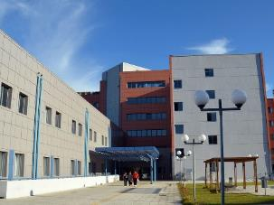
Agios Silas, 65500 Kavala
+30 2513 501100 (centre),
+30 2513 501700 (microbiological & radiological tests), +30 2513 501 675 (nuclear medicine tests)
www.kavalahospital.gr
L

The General Hospital of Kavala is located in the area of Agios Silas, at the entrance of the city of Kavala from Egnatia Odos. It is served by the public bus Line 11 Hospital - Perigiali, which has as its starting point the Hospital.
It starts at 5:30 in the morning and the last one leaves at 23:15.
he General Hospital of Kavala is one of the largest nursing units in the region of Eastern Macedonia and Thrace.
For many years it has been offering medical care and health services in order to be a pioneer in terms of equal and direct access, efficiency, organization and quality of health services.
The building complex consists of two buildings of different heights, centrally connected to each other by a building that includes the main node of vertical communications through the elevators of public and staff.
A parking lot of 130 cars is created between the Hospital and the entrances, while in the Eastern part of the plot there is a second parking lot accessible from the ring road, with 125 seats.
The places include 9 places for people with disabilities.

st. LOUKAS POLYCENTER (agios loukas POLYCENTER)
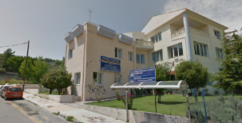

1 Chanion str., 65404 Kavala
L
+30 2510 241466
It houses, among other things:
Municipal Health Clinic.
Diabetes Center for the prevention and diagnosis of diabetes, with systematic sugar measurements and a specialized daily diet program.
Breast Cancer Prevention Center where clinical examinations for the prognosis of breast cancer are performed, while educational tips are given for breast palpation techniques for early diagnosis and treatment.
Center for Creative Employment of Children with Disabilities (KDAP-MEA).

Municipal Health Clinic
The Municipality of Kavala operates seven (7) Municipal Health Clinics that offer free primary health care to all citizens:
Municipal Health Clinic of St. Luka
Municipal Health Clinic of Sfageia
Municipal Health Clinic of Nea Karvali
Municipal Health Clinic of Halkero
Municipal Health Clinic of Krinides
Municipal Health Clinic of Palio
Municipal Health Clinic of Panagia


UNIT OF CHRONIC HEMODIALYSIS “AKESIOS”
10th km National Road Kavala-Drama-Polistilo, P.C. 64003
+30 2510 391919
www.akesios-dialysis.gr
L

It is specially organized to provide comprehensive high quality medical care to patients with end-stage chronic kidney disease.

REHABILITATION AND RECOVERY CLINIC “lydia”
Amigdaleonas, 64012 Kavala
+30 2510 225511
www.lydia-apokatastasi.gr
L

The scientific staff with physiotherapists, hydrotherapists, occupational therapists, speech therapists, psychologist, nutritionist, social worker, and the constant supervision of the center's doctors treat all diseases of the nervous, muscular, stimulatory, circulatory and respiratory systems.

KRINIDA PELOTHERAPY (mud baths)
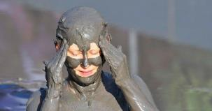
64003 Philippoi Kavala
+30 2510 516162
www.pilotherapia.gr

It is located 17km from Kavala and 3 km from the settlement of Krinides and 3 km from Lydia. It has a camping with accommodation for 165 people, a restaurant and a bar.
L
Operating period:
1 JUNE – 15 OCTOBER

THERMAL SPRINGS eleftheron of Kavala (LOUTRA)
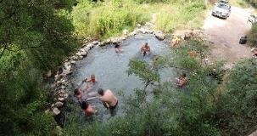
64008 Loutra Eleftheron of Kavala (Thermal springs Eleftheron of Kavala)

These are abandoned thermal springs - in recent years - located in Kavala in a fascinating and unique landscape of a vast forest with towering plane trees.
L

Sport

MUNICIPAL SPORTS CENTER OF KALAMITSA “alexandra dimoglou”
2 Thalassa Marmara str., 65404 Kavala
+30 2510 245812

It has a capacity of 1,500 spectators and is the sports headquarters of the Kavala Sports Club (Α.Ο.Κ.), which is a sports club based in Kavala. Α.Ο.Κ. was founded in 1965 after the merger of associations: Iraklis of Kavala, Filippi of Kavala and A.E.K. of Kavala. It has football, basketball, volleyball, track and field, karate, and rugby divisions. Its emblem depicts an ancient trireme, while its athletes compete in blue and white. It has a team of both adult men and younger athletes. In recent years, A.O.K. has under its auspices the Athletic Association for People with Disabilities.
L

MUNICIPAL NATATORIUM
+30 2513 500460 & 461

MUNICIPAL STADIUM
“ANTHI KARAGIANNI”
+30 2510 223740

WATER SPORTS CLUB
Dagli, 65401 Kavala
+30 2510 231018
www.othak.gr



Associations of people with disabilities & chronic diseases

PREFECTURE ASSOCIATION OF people with disabilites
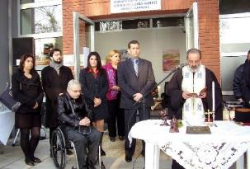
20 Eth. Antistaseos str., 65302 Kavala
+30 2513 503218
amea_nkav@hotmail.gr
https://amea-kavalas.gr
L

It was founded in 2010 and its purpose is, among other things according to its statutory provisions, the organization and information of people with disabilities living in the prefecture. People with disabilities of any category can register in the Prefectural Association.

REGIONAL ASSOCIATION OF THE BLIND OF EASTERN MACEDONIA
2 Eth. Antistaseos str., 65302 Kavala
+30 2510 232303
peanmak@hotmail.gr
https://cutt.ly/BbGwjXB (Facebook)
Non-profit association dealing with the representation and rights of the visually impaired.

SPORTS ASSOCIATION OF PEOPLE WITH DISABILITIES
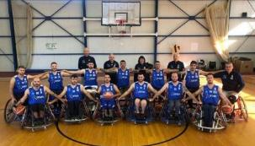
2 Thalassa Marmara str., 65404 Kavala
+30 2510 831122 & 2510 240941
https://cutt.ly/5bGrZtT (Facebook) & www.aokavala.gr
L

It is a sports club of Kavala, under the auspices of the Sports Club of Kavala, with organized sections for people with disabilities. It was founded in 1998 and maintains athletics, swimming, and basketball departments for athletes with mobility problems, vision problems and mental problems.
From October 2018 it was renamed from Kavala’s Sports Association of People with Disabilities "IRIS" to AOK NAS People with Disabilities and has its sports headquarters at the Municipal Sports Center of Kalamitsa “Alexandra Dimoglou”.

KIDNEY PATIENT ASSOCIATION
Ethn. Makariou & K. Palaiologou corner
+30 2510 230842
sylnef-kav@hotmail.gr
https://cutt.ly/MbGw0yy (Facebook)

ASSOCIATION OF PEOPLE WITH DIABETES of the young “SWEET HUG” (GLYKIA AGKALIA)
2 Miaouli str., 65201 Kavala
+30 6958 046559
glikia.agkalia@gmail.com
https://cutt.ly/JbGeANg (Facebook)

CARE FOR A SPECIAL CHILD “St. MARINA” (AGIA MARINA)
Ag. Tryfonos (Perigiali), Kavala
+30 2510 833941
agiamarina1975@yahoo.gr
http://amfoundation.gr
It was founded in 1975 as a charity by parents of people with disabilities. It is recognized by the Ministry of Health and operates as a specialized center for social and professional integration of people with disabilities.

ASSOCIATION OF PARENTS, GUARDIANS & FRIENDS OF PEOPLE WITH AUTISM
autismkavala@gmail.com
https://cutt.ly/bbHERa1 (Facebook)

ASSOCIATION OF CANCER VOLUNTEERS
9 K. Palaiologou str., 65403 Kavala
+30 2510 833941
info@se-kk.gr & sekk@gmail.com
www.se-kk.gr

